**Consultpedia**

A Project-II Report

Submitted in partial fulfillment of requirement of the

Degree of

**BACHELOR OF TECHNOLOGY**

**in**

**COMPUTER SCIENCE & ENGINEERING**

BY

**Taranjot Singh**

**EN18CS301281**

Under the Guidance of

**Mr. Preetesh Purohit (Internal Guide)**

**Mr. Gyanendra Chandrawat (External Industry Guide)**



**Department of Computer Science & Engineering**

**Faculty of Engineering**

**MEDI-CAPS UNIVERSITY, INDORE- 453331**

**May 2022**

**Report Approval**

The project work **“Consultpedia”** is hereby approved as a creditable study of an engineering/computer application subject carried out and presented in a manner satisfactory to warrant its acceptance as prerequisite for the Degree for which it has been submitted.

It is to be understood that by this approval the undersigned do not endorse or approved any statement made, opinion expressed, or conclusion drawn there in; but approve the “Project Report” only for the purpose for which it has been submitted.

Internal Examiner

Name:

Designation

Affiliation

External Examiner

Name:

Designation

Affiliation

**ii**

**Declaration**

I hereby declare that the project entitled **“Consultpedia”** submittedin partial fulfillment for the award of the degree of Bachelor of Technology in Computer Science & Engineering completed under the supervision of **Mr. Preetesh Purohit,** Faculty of Engineering, Medi-Caps University Indore and **Mr. Gyanendra Chandrawat**, Associate Software Engineer, ConsultAdd Services Pvt. Ltd. is an authentic work.

Further, I/we declare that the content of this Project work, in full or in parts, have neither been taken from any other source nor have been submitted to any other Institute or University for the award of any degree or diploma.

**Taranjot Singh**

**EN18CS301281**

**Date-19/04/22**

**iii**

**Certificate**

We, **Mr. Preetesh Purohit & Mr. Gyanendra Chandrawat** certify that the project entitled **“Consultpedia”** submittedin partial fulfillment for the award of the degree of Bachelor of Technology in Computer Science & Engineering by **Taranjot Singh** istherecordcarried out by him under our guidance and that the work has not formed the basis of award of any other degree elsewhere.

________________________________ ________________________________

Mr. Preetesh Purohit

Computer Science & Engineering

Medi-Caps University, Indore

Mr. Gyanendra Chandrawat

Engineering

ConsultAdd Services Pvt. Ltd.

_____________________

Dr. Pramod Nair

Head of the Department

Computer Science & Engineering

Medi-Caps University, Indore

**iv**

**Offer Letter of the Internship**



**v**

**Acknowledgements**

I would like to express my deepest gratitude to Honorable Chancellor, **Shri R C Mittal,** who has provided me with every facility to successfully carry out this project, and my profound indebtedness to **Prof. (Dr.) Dilip K. Patnaik,** Vice Chancellor, Medi-Caps University, whose unfailing support and enthusiasm has always boosted up my morale. I also thank **Prof. (Dr.) D. K. Panda,** Pro Vice Chancellor, **Dr. Suresh Jain,** Dean, Faculty of Engineering, Medi-Caps University, for giving me a chance to work on this project. I would also like to thank my Head of the Department **Prof.** (**Dr.) Pramod S. Nair** for his continuous encouragement for betterment of the project.

I express my heartfelt gratitude to my **External Guide, Mr. Gyanendra Chandrawat**, Associate Software Engineer, ConsultAdd Services Pvt. Ltd. as well as to my **Internal Guide, Mr. Preetesh Purohit,** Faculty, Department of Computer Science & Engineering, MU, without whose continuous help and support, this project would ever have reached to the completion.

I would also like to thank to my team at ConsultAdd Services Pvt. Ltd. who extended their kind support and help towards the completion of this project.

It is their help and support, due to which we became able to complete the design and technical report.

Without their support this report would not have been possible.

**Taranjot Singh**

B.Tech. IV Year

Department of Computer Science & Engineering

Faculty of Engineering

Medi-Caps University, Indore

**vi**

**Abstract**

As a part of my under-graduate program, I joined ConsultAdd Services Pvt. Ltd. on 4 January 2022 as a Associate Software Engineer– Intern. In the initial training of 1 month, I went through several internal trainings and evaluations related to different technologies and software development. After the successful completion of training, mentors were allotted and project-shadowing phase was started to provide me a good experience to more closely monitor real-life projects. Once I was ready for projects, my mentor gave the approval for me & by March 2022, a project called “Consultpedia” was assigned to me.

Consultpedia strives to provide solutions to develop and transfer easy and efficient way in the digital age and to help reducing the human pressure and time, to help support shop collections, the digital initiatives, and external partner institution digital projects. It provides services that include the digitization of analog objects, metadata management, cloud security, and deployment and access of digital collections. Consultpedia is a web application written for all operating systems, designed to help users maintain and organize shop virtually. This software is easy to use for both beginners and advanced users. It features familiar and well throughout an attractive user interface, combined with strong searching Insertion and reporting capabilities. The order generation facility of shop system helps to get a good idea of which are the various items brought by the customers & also makes possible for the customers to get the product easily.

ConsultAdd is a niche IT Training | Recruiting | Consulting solution provider for global clients in diverse vertical and horizontal streams such as finance and accounts, IT, health care, financial services, human resource, and knowledge process outsourcing and staffing. ConsultAdd Information Technology Solutions has an unmatched ability to help its client's businesses grow by improving their back-office processes, while significantly reducing costs.

**vii**

**Table of Content**

|  |  |  |
| --- | --- | --- |
|  | **Content** | **Page No.** |
|  | Report Approval | ii |
|  | Declaration | iii |
|  | Certificate | iv |
|  | Offer Letter of the Internship | v |
|  | Acknowledgement | vi |
|  | Abstract | vii |
|  | Table of Content | viii-x |
|  | List of Figures | xi |
|  | Abbreviations | xii |
| Chapter 1 | Introduction | 1-2 |
|  | 1.1 Pre-Joining Training | 1 |
|  | 1.2 Job Responsibilities | 1 |
|  | 1.3 Components of the Pre-Joining Training | 2 |
| Chapter 2 | Training | 3-7 |
|  | 2.1 Introduction | 3 |
|  | 2.2 Components of Training | 3 |
|  | 2.2.1 Frontend Training | 3-5 |
|  | 2.2.2 Backend Training | 5-6 |
|  | 2.2.3 Cloud Deployment Training | 6-7 |
| Chapter 3 | Java Framework: Spring | 8-14 |
|  | 3.1 Introduction to Java | 8 |
|  | 3.1.1 New Features of Java 8 | 8-9 |
|  | 3.1.2 Components of Java | 9 |
|  | 3.2 Framework (Spring) | 10 |
|  | 3.2.1 Inversion of Control | 10 |
|  | 3.2.2 Dependency Injection | 10-11 |
|  | 3.2.3 Autowiring | 11 |
|  | 3.2.4 Object Relational Mapping (ORM) | 11-12 |
|  | 3.2.5 Spring Boot | 12 |
|  | 3.2.6 Features | 12-14 |
|  | 3.3 Work Done | 14 |
| Chapter 4 | Python Frameworks: Flask & Django | 15-20 |
|  | 4.1 Introduction to Python | 15-16 |
|  | 4.1.1 Features of Python | 16 |
|  | 4.2 Framework (Flask) | 16-17 |
|  | 4.2.1 Advantages of Flask | 17 |
|  | 4.3 Framework (Django) | 18-19 |
|  | 4.3.1 Advantages of Django | 19 |
|  | 4.4 Work Done | 19-20 |

**viii**

|  |  |  |
| --- | --- | --- |
| Chapter 5 | JavaScript Frameworks: Angular & React | 21-25 |
|  | 5.1 Introduction to JavaScript | 21-22 |
|  | 5.2 Framework (Angular) | 22-23 |
|  | 5.3 Framework (React) | 23-25 |
|  | 5.4 Work Done | 25 |
| Chapter 6 | Amazon Web Services (AWS) | 26-34 |
|  | 6.1 Introduction to AWS | 26 |
|  | 6.1.1 Cloud Computing | 26-27 |
|  | 6.2 Benefits of AWS | 27-28 |
|  | 6.3 Most Used AWS Services | 28-34 |
|  | 6.4 Work Done | 34 |
| Chapter 7 | Project Shadowing | 35-36 |
|  | 7.1 What is Project Shadowing? | 35 |
|  | 7.2 How Shadowing Works? | 35 |
|  | 7.3 Benefits of Shadowing | 35-36 |
|  | 7.4 My Experience | 36 |
| Chapter 8 | Project Phase: Consultpedia | 37-42 |
|  | 8.1 Overview | 37 |
|  | 8.2 Project Details | 37 |
|  | 8.3 Project Introduction | 37-38 |
|  | 8.4 Project Objectives | 38-39 |
|  | 8.5 Features of Project | 39 |
|  | 8.6 Proposed System | 39-40 |
|  | 8.7 Scope | 40 |
|  | 8.8 Feasibility Study | 40-42 |
|  | 8.9 Technologies Used | 42 |
| Chapter 9 | Requirement Analysis | 43-45 |
|  | 9.1 Functional Requirements | 43 |
|  | 9.2 Non-Functional Requirements | 43-44 |
|  | 9.3 Data Requirements | 44 |
|  | 9.4 Requirement Validation | 44-45 |
|  | 9.5 Hardware Requirements | 45 |
| Chapter 10 | System Design | 46-52 |
|  | 11.1 Database Design | 46 |
|  | 11.2 Project Diagrams | 47-52 |
| Chapter 11 | Testing | 53-57 |
|  | 12.1 Testing Methods Applied | 53 |
|  | 12.2 Test Cases | 54-57 |
| Chapter 12 | Project Snapshots | 58-63 |
| Chapter 13 | Additional Work (Research Paper) | 64-65 |
|  | 13.1 Introduction | 64 |
|  | 13.2 Overview | 64 |

**ix**

|  |  |  |
| --- | --- | --- |
|  | 13.3 Some Screenshots | 64-65 |
| Chapter 14 | Executive Summary & Conclusion | 66-67 |
|  | 14.1 Interpretation of the Project | 66 |
|  | 14.2 Future Scope | 66 |
|  | 14.3 My Learning Experience | 66-67 |
| Chapter 15 | Bibliography | 68-69 |

**x**

**List of Figures**

|  |  |  |
| --- | --- | --- |
|  | **Figure** | **Page No.** |
| Fig 3.1.1 | Java Compilation Process | 9 |
| Fig 3.2.1 | Autowiring | 11 |
| Fig 4.3.1 | Django MVC Diagram | 19 |
| Fig 4.3.2 | Django Project Diagram | 19 |
| Fig 11.1 | Use-Case Diagram | 62 |
| Fig 11.2 | Activity Diagram | 63 |
| Fig 11.3 | Sequence Diagram (Customer) | 64 |
| Fig 11.4 | Collaboration Diagram (Customer) | 65 |
| Fig 11.5 | Component Diagram | 66 |
| Fig 11.6 | Deployment Diagram | 67 |

**xi**

**Abbreviations**

|  |  |
| --- | --- |
| **Abbreviations** | **Full Form** |
| API | Application Programming Interface |
| CLI | Command Line Interface |
| IDE | Integrated development Environment |
| SDK | Software Development Kit |
| SDLC | Software Development Lifecycle |
| REST | Representational State Transfer |
| CRM | Customer Relationship Management |
| DBMS | Database Management System |
| RDBMS | Relational Database Management System |
| SQL | Structured Query Language |
| POWER BI | POWER Business Intelligence |
| JS | JavaScript |
| AWS | Amazon Web Services |
| VA | Virtual Agent |
| HTTP | Hypertext Transfer Protocol |
| SOAP | Simple Object Access Protocol |
| GPU | Graphics Processing Unit(s) |
| CPU | Central Processing Unit(s) |

**xii**

**Chapter-1**

**Introduction**

* 1. **Pre-Joining Training:**

The training team of ConsultAdd Services Pvt. Ltd are a set of working professionals and a vibrant tech group, whose pursuit is progress for people everywhere. That’s why we take a closer look at things, learn them, spread them and ask questions and think ahead. We’ve been around for more than 4 years at ConsultAdd Inc. and leading from front to back. We spend most of a significant portion of our time coding, documenting and training consultants. We find answers to the most pressing questions which also drive us to be lifelong learners. We work on live projects for clients of different domains. ANCORA IMPARO → I AM STILL LEARNING This is the phrase that is our constant motivation, i.e., learning regularly is the most important thing for us. The pre-joining training was of 3 weeks, which comprised of several important topics that are required for the understanding the process flow of software development and other required topics.

**1.2 Job Responsibilities:**

Other than the technical training that I went through, I was also trained for some other responsibilities-

• Technical Screenings: Our team is responsible for taking technical screenings of the candidates that we hire from USA. And during my initial training I was coached for the same. We ask several technical questions based on different technologies and basics and then make an informed decision.

• Professional Training: After we hire the candidates, we provide them with our Professional Training if required. We provide training in several technology domains such as Basics of Software Development, Python – Basics to Advance, Java – Basics to Advance, Web Development, AWS Developer Core and also, we arrange seminars and Bootcamps throughout the year to spread knowledge as much as possible.

• Remote Projects: We dedicatedly work on many remote projects of our company, which are assigned to us after we reach a certain amount of seniority. Before handling personal projects,

**1**

we are assigned support projects, in which we support other seniors in their respective remote

projects.

**1.3 Components of the Pre-Joining Training:**

The pre-joining training comprised of several forefront technologies or components used in the software industry. These include:

* Frontend
* Backend
* API
* REST API
* SOAP Web Service
* HTTP & Methods
* Client Server Architecture
* Microservices
* GraphQL
* SDLC
* Waterfall vs Agile vs DevOps
* Agile & Scrum Ceremonies
* Environments
* Git/GitHub
* PostgreSQL
* Unix Commands
* MongoDB
* Ticketing System – (JIRA, Rally, Trello)
* Types of Testing
* AWS Services

**2**

**Chapter-2**

**Training**

**2.1 Introduction:**

After the pre-joining training, a 1-month training was given on a variety of technologies which will be used in future while doing real-life projects. All the important components of software development were covered in this training which includes Frontend, Backend as well as Deployment.

**2.2 Components of Training:**

This training of 4 weeks mainly comprised of 3 basic components under which all topics were covered. These components were:

1. Frontend Training
2. Backend Training
3. Cloud Deployment Training

The frontend & deployment training were of 1-week each whereas the backend training comprised of 2 weeks as it included java as well as python.

**2.2.1 Frontend Training:**

The part of a website that the user interacts with directly is termed the front end. It is also referred to as the ‘client side’ of the application. It includes everything that users experience directly: text colors and styles, images, graphs and tables, buttons, colors, and navigation menu. HTML, CSS, and JavaScript are the languages used for Front End development. The structure, design, behavior, and content of everything seen on browser screens when websites, web applications, or mobile apps are opened up, is implemented by front End developers. Responsiveness and performance are two main objectives of the Front End. The developer must ensure that the site is responsive i.e., it appears correctly on devices of all sizes no part of the website should behave abnormally irrespective of the size of the screen.

**2.2.1.1 Front end Languages:**

**3**

The front-end portion is built by using some languages which are discussed below:

* **HTML:** HTML stands for Hypertext Markup Language. It is used to design the front-end portion of web pages using a markup language. HTML is the combination of Hypertext and Markup language. Hypertext defines the link between the web pages. The markup language is used to define the text documentation within the tag which defines the structure of web pages.
* **CSS:** Cascading Style Sheets fondly referred to as CSS is a simply designed language intended to simplify the process of making web pages presentable. CSS allows you to apply styles to web pages. More importantly, CSS enables you to do this independent of the HTML that makes up each web page.
* **JavaScript:** JavaScript is a famous scripting language used to create magic on the sites to make the site interactive for the user. It is used to enhancing the functionality of a website to running cool games and web-based software.

There are many other languages through which one can do front-end development depending upon the framework for example Flutter uses Dart, React uses JavaScript and Django uses Python and much more.

**2.2.1.2 Front End Frameworks and Libraries:**

* **AngularJS:** AngularJS is a JavaScript open-source front-end framework that is mainly used to develop single-page web applications (SPAs). It is a continuously growing and expanding framework which provides better ways for developing web applications. It changes the static HTML to dynamic HTML. It is an open-source project which can be free. It extends HTML attributes with Directives, and data is bound with HTML.
* **React.js:** React is a declarative, efficient, and flexible JavaScript library for building user interfaces. ReactJS is an open-source, component-based front-end library responsible only for the view layer of the application. It is maintained by Facebook.   
  Bootstrap: Bootstrap is a free and open-source tool collection for creating responsive websites and web applications. It is the most popular HTML, CSS, and JavaScript framework for developing responsive, mobile-first websites.

**4**

* **jQuery:** jQuery is an open-source JavaScript library that simplifies the interactions between an HTML/CSS document, or more precisely the Document Object Model (DOM), and JavaScript. Elaborating the terms, jQuery simplifies HTML document traversing and manipulation, browser event handling, DOM animations, Ajax interactions, and cross-browser JavaScript development.
* **SASS:** It is the most reliable, mature, and robust CSS extension language. It is used to extend the functionality of an existing CSS of a site including everything from variables, inheritance, and nesting with ease.
* **Flutter:**Flutter is an open-source UI development SDK managed by google. It is powered by Dart programming language. It builds performant and good-looking natively compiled applications for mobile (Ios, Android), web, and desktop from a single code base. The key selling point of flutter is flat development is made easier, expressive, and flexible UI and native performance. In march 2021 flutter announce Flutter 2 which upgrades flutter to build release applications for the web, and the desktop is in beta state.
* Some other libraries and frameworks are Semantic-UI, Foundation, Materialize, Backbone.js, Ember.js, etc.

**2.2.2 Backend Training:**

Backend is the server-side of the website. It stores and arranges data, and also makes sure everything on the client-side of the website works fine. It is the part of the website that you cannot see and interact with. It is the portion of software that does not come in direct contact with the users. The parts and characteristics developed by backend designers are indirectly accessed by users through a front-end application. Activities, like writing APIs, creating libraries, and working with system components without user interfaces or even systems of scientific programming, are also included in the backend.

**2.2.2.1 Back-end Languages:**

The back-end portion is built by using some languages which are discussed below:

**5**

* **PHP:** PHP is a server-side scripting language designed specifically for web development. Since PHP code executed on the server-side, so it is called a server-side scripting language.
* **C++:** It is a general-purpose programming language and widely used nowadays for competitive programming. It is also used as a backend language.
* **Java:** Java is one of the most popular and widely used programming languages and platforms. It is highly scalable. Java components are easily available.
* **Python:** Python is a programming language that lets you work quickly and integrate systems more efficiently.
* **JavaScript:** JavaScript can be used as both (front end and back end) programming languages.
* **Node.js:** Node.js is an open-source and cross-platform runtime environment for executing JavaScript code outside a browser. You need to remember that NodeJS is not a framework, and it’s not a programming language. Most people are confused and understand it’s a framework or a programming language. We often use Node.js for building back-end services like APIs like Web App or Mobile App. It’s used in production by large companies such as Paypal, Uber, Netflix, Walmart, and so on.

**2.2.2.2 Back End Frameworks:**

* The list of back-end frameworks are: Express, Django, Rails, Laravel, Spring, etc.
* The other back-end program/scripting languages are C#, Ruby, REST, GO, etc.

**2.2.3 Cloud Deployment Training:**

Deployment in software and web development means pushing changes or updates from one deployment environment to another. When setting up a website you will always have your live website, which is called the live environment or production environment. If you want the ability to make changes without these affecting your live website, then you can add additional

**6**

environments. These environments are called development environments or deployment environments. The additional development environments will typically be a local environment, a [development environment](https://umbraco.com/knowledge-base/development-environment/), and a [staging environment](https://umbraco.com/knowledge-base/staging-environment/) (also known as a staging site).

**2.2.3.1 Cloud Service Providers:**

* Amazon Web Services (AWS)
* ServerSpace
* Microsoft Azure
* Google Cloud Platform
* IBM Cloud Services
* Adobe Creative Cloud
* Kamatera
* Vmware

**7**

**Chapter-3**

**Java Framework: Spring**

**3.1 Introduction to Java:**

Java is a programming language and computing platform first released by Sun Microsystems in 1995. There are lots of applications and websites that will not work unless you have Java installed, and more are created every day. Java is fast, secure, and reliable. From laptops to datacenters, game consoles to scientific supercomputers, cell phones to the Internet, Java is everywhere!

Java platform is a collection of programs that help to develop and run programs written in the Java programming language. Java platform includes an execution engine, a compiler, and a set of libraries. JAVA is platform-independent language. It is not specific to any processor or operating system.

Java is a programming language created by James Gosling from Sun Microsystems (Sun) in 1991. The target of Java is to write a program once and then run this program on multiple operating systems. The first publicly available version of Java (Java 1.0) was released in 1995. Sun Microsystems was acquired by the Oracle Corporation in 2010. Oracle has now the steer Manship for Java. Oracle continues this project called OpenJDK.

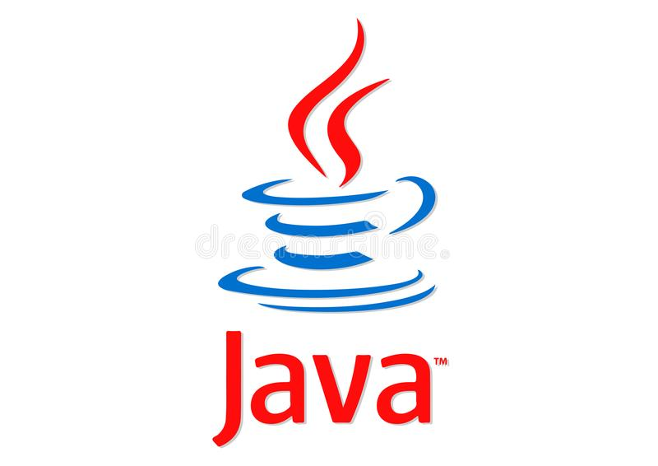

**3.1.1 New Features of Java 8:**

* Interface Default and Static Methods
* Method References
* Lambda Expressions
* Date and Time

**8**

* API Type Annotation
* Optional<T>

**3.1.2 Components of Java:**

* **JDK:** JDK provides the environment to develop and execute (run) the Java program. JDK is a kit (or package) which includes two things, Development Tools (to provide an environment to develop your java programs) and JRE (to execute your java program).
* **JRE:** JRE is an installation package that provides environment to only run (not develop) the java program (or application) onto your machine. JRE is only used by them who only want to run the Java Programs i.e., end-users of your system.
* **JVM:** Java Virtual Machine (JVM) is a very important part of both JDK and JRE because it is contained or inbuilt in both. Whatever Java program you run using JRE or JDK goes into JVM 29 and JVM is responsible for executing the java program line by line hence it is also known as interpreter. Through the Java VM, the same application is capable overrunning on multiple platforms and that is why the JAVA is said to be platform independent.
* **Compilation Process:** During the compilation phase, the Java compiler compiles the source code and generates bytecode. This intermediate bytecode is saved in the form of a class file. In the second phase, Java virtual machine (JVM) also called Java interpreter takes the class as input and generates output by executing the bytecode.

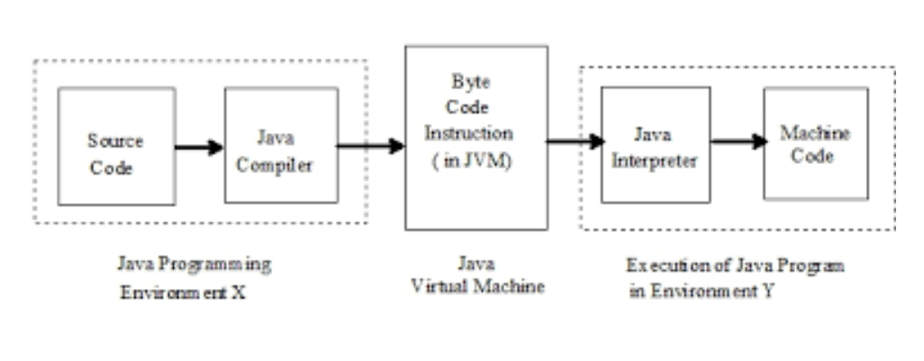

**9**

**3.2 Framework (Spring):**

Spring is a lightweight framework. It can be thought of as a framework of frameworks because it provides support to various frameworks The Spring framework comprises several modules such as IOC, AOP, DAO, Context, ORM, WEB MVC etc.



**3.2.1 Inversion of Control:**

IOC makes the code loosely coupled. In such a case, there is no need to modify the code if our logic is moved to a new environment. In the Spring framework, IOC container is responsible to inject the dependency. We provide metadata to the IOC container either by XML file or annotation.

The IoC container is responsible to instantiate, configure, and assemble the objects.

The main tasks performed by the IoC container are:

* to instantiate the application class
* to configure the object
* to assemble the dependencies between the objects.

There are two types of IoC containers. They are:

1. BeanFactory

2. ApplicationContext

The ApplicationContext interface is built on top of the BeanFactory interface. It adds some extra functionality than BeanFactory such as simple integration with Spring’s AOP, message resource handling, event propagation, application-layer specific context (e.g., WebApplicationContext) for a web application. So, it is better to use ApplicationContext than BeanFactory.

**3.2.2 Dependency Injection:**

**10**

Dependency Injection (DI) is a design pattern that removes the dependency from the programming code so that it can be easy to manage and test the application. Dependency Injection makes our programming code loosely coupled.

Spring framework provides two ways to inject dependency

* By Constructor
* By Setter method

**3.2.3 Autowiring:**

Autowiring feature of the spring framework enables you to inject the object dependency implicitly. It internally uses setter or constructor injection. Autowiring can’t be used to inject primitive and string values. It works with reference only.

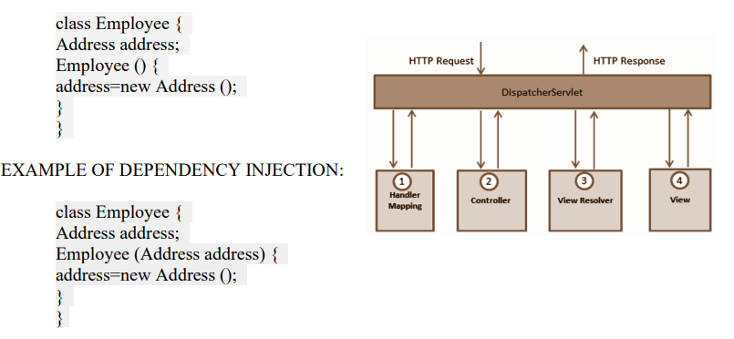

**3.2.4 ORM (Object Relational Mapping):**

Spring provides API to easily integrate Spring with ORM frameworks such as Hibernate, JPA (Java Persistence API), JDO (Java Data Objects), Oracle Toplink and iBATIS.

Advantages of ORM Frameworks with Spring:

There is a lot of advantages to the Spring framework in respect to ORM frameworks. There are as follows:

* Less coding is required: With the help of the Spring framework, you don’t need to write extra codes before and after the actual database logic such as getting the connection, starting the transaction, committing the transaction, closing connection, etc.

**11**

* Easy to test: Spring’s IoC approach makes it easy to test the application.

**3.2.5 Spring Boot:**

* Spring Boot is a project that is built on the top of the Spring Framework. It provides an easier and faster way to set up, configure, and run both simple and web-based applications.
* It is a Spring module that provides the RAD (Rapid Application Development) feature to the Spring Framework. It is used to create a stand-alone Spring-based application that you can just run because it needs minimal Spring configuration.
* In short, Spring Boot is the combination of Spring Framework and Embedded Servers.
* In Spring Boot, there is no requirement for XML configuration (deployment descriptor). It uses convention over configuration software design paradigm that means it decreases the effort of the developer.

We should use Spring Boot Framework because:

* The dependency injection approach is used in Spring Boot.
* It contains powerful database transaction management capabilities.
* It simplifies integration with other Java frameworks like JPA/Hibernate ORM, Struts, etc.
* It reduces the cost and development time of the application.

**3.2.6 Features:**

**1. Web Development:**

It is a well-suited Spring module for web application development. We can easily create a self-contained HTTP application that uses embedded servers like Tomcat, Jetty, or Undertow. We can use the spring-boot-starter-web module to start and run the application quickly.

**12**

**2. SpringApplication:**

The SpringApplication is a class that provides a convenient way to bootstrap a Spring application. It can be started from the main method. We can call the application just by calling a static run() method.

Public static void main (String [] args) {

SpringApplication.run (ClassName.class, args);

}

**3. Admin Support:**

Spring Boot provides the facility to enable admin-related features for the application. It is used to access and manage applications remotely. We can enable it in the Spring Boot application by using spring. Application. Admin. Enabled property.

**4. Externalized Configuration:**

Spring Boot allows us to externalize our configuration so that we can work with the same application in different environments. The application uses YAML files to externalize configuration.

**5. Properties Files:**

Spring Boot provides a rich set of Application Properties. So, we can use that in the properties file of our project. The properties file is used to set properties like server-port =8082 and many others. It helps to organize application properties.

**6. YAML Support:**

It provides a convenient way of specifying the hierarchical configuration. It is a superset of JSON. The SpringApplication class automatically supports YAML. It is an alternative of properties file.

**7. Type-safe Configuration:**

The strong type-safe configuration is provided to govern and validate the configuration of the application. Application configuration is always a crucial task which should be type safe. We can also use annotation provided by this library.

**8. Logging:**

**13**

Spring Boot uses Common logging for all internal logging. Logging dependencies are managed by default. We should not change logging dependencies if no customization is needed.

**9. Security:**

Spring Boot applications are spring bases web applications. So, it is secure by default with basic authentication on all HTTP endpoints. A rich set of Endpoints is available to develop a secure Spring Boot application.

**3.3 Work Done:**

In this Java training on Spring-Boot, I learned how to:

* Create a REST API in Spring Boot.
* Implementing Database Connectivity in it.
* Integrate spring security for user using sign in & sign-up processes.
* Add test-cases for the created methods.
* Create docker image & run JAVA App in a docker engine.
* Implement config using consul & connect 2 different applications using it.

**14**

**Chapter-4**

**Python Frameworks: Flask & Django**

**4.1 Introduction to Python:**

* Python is an Interpreted, Object Oriented, High-level and Dynamic Language. It is an Open-Source Language.
* Python was invented in December 1989. But released its first version in 1991. [Python is Older than Java (1996)].
* Python was created by Guido van Rossum at Centrum Wiskunde & Informatica (CWI) in the Netherlands.
* Python 1.0 – Jan 1994
* Python 2.0 – Oct 2000
* Python 3.0 – Dec 2008
* Python 3.10.0 is the current stable release. Python updates its versions rapidly.
* Python is easy to understand and learn
* It is a high-level language; hence we do not need to remember the system architecture. Closely resembles English Language and is much easy to understand as compared to low level languages.
* Python is Everywhere: Web Development, Software Development, Machine Learning, Deep Learning, GUI. We can change the value of a variable as we develop the program. We can just simply give names to the variable and assign values to them. An interpreter of python takes cares of the type of variable your program is using.

**15**

* Does not have a compiler. An interpreter processes the code line by line and generates the byte codes. While compiler languages whole code executes at one go which is frustrating when it comes to debug the code.



**4.1.1 Features of Python:**

* **OBJECT ORIENTED:** Relies on data fields that are treated as objects and manipulated only through prescribed methods.
* **FUNCTIONAL:** Every statement is treated as a mathematical equation and any forms of state or mutable data are avoided.
* **PROCEDURAL:** Tasks are treated as step-by-step iterations where common tasks are placed in functions that are called as needed.
* **IMPERATIVE:** Computation is performed as a direct change to program state.
* Python is widely used by companies around the world to build web apps, analyze data, automate operations via DevOps and create reliable, scalable enterprise applications.

**4.2 Framework (Flask):**

Flask is a web application framework written in Python. Armin Ronacher, who leads an international group of Python enthusiasts named Pocco, develops it. Flask is based on Werkzeug WSGI toolkit and Jinja2 template engine. Both are Pocco projects.

Flask is considered more [Pythonic](http://blog.startifact.com/posts/older/what-is-pythonic.html) than the [Django](https://www.fullstackpython.com/django.html) web framework because in common situations the equivalent Flask web application is more explicit. Flask is also easy to get started with as a beginner because there is little boilerplate code for getting a simple app up and running.

For example, here is a valid “Hello, world!” web application with Flask:

**16**

from flask import Flask

app = Flask(__name__)

@app.route(‘/’)

def hello_world():

return ‘Hello, World!’

if __name__ == ‘__main__’:

app.run()

The above code shows “Hello, World!” on localhost port 5000 in a web browser when run with the python app.py command and the Flask library installed.

The equivalent “Hello, World!” web application using the [Django](https://www.fullstackpython.com/django.html) [web framework](https://www.fullstackpython.com/web-frameworks.html) would involve significantly more boilerplate code.

Flask was also written several years after Django and therefore learned from the Python community’s reactions as the framework evolved. Jökull Sólberg wrote a great piece articulating to this effect in his [experience switching between Flask and Django](http://web.archive.org/web/20160305145017/http:/jokull.calepin.co/my-flask-to-django-experience.html).

**4.2.1 Advantages of Flask:**

* Higher flexibility.
* Higher compatibility with latest technologies.
* High scalability for simple web applications.
* Technical experimentation.
* Customization.
* Slightly higher framework performance.
* Easier to use for simple cases.
* Smaller size of the code base.



**17**

**4.3 Framework (Django):**

* Django is a free and open-source web application framework written in Python.
* Django is a high- level Python web framework that encourages rapid.
* development and clean, pragmatic design. Django makes I t easier to build better web apps quickly and with less code.
* Django was created in 2003 when the web developers at the Lawrence Journal- World newspaper started using Python for their development.
* Good written documentation is a key part of Django!
* Django was created in 2003 when the web developers at the Lawrence Journal-World newspaper started using Python for their development. The fact that is originated at a newspaper is important!
* Because the original developers were surrounded by writers, good written. Documentation is a key part of Django! This means you have excellent references to check on the official Django docs!
* 2003 – Started by Adrian Holovaty and Simon Willison as an internal project at the Lawrence Journal- World newspaper.
* 2005 – Released July 2005 and named it Django, after the jazz guitarist Django Reinhardt.
* 2005 – Mature enough to handle several high- traffic sites.
* Current – Django is now an open-source project with contributors across the world.
* It is used by many sites, including Pinterest, PBS, Instagram, Bitbucket, Washington Times, Mozilla, NASA and more!

**18**

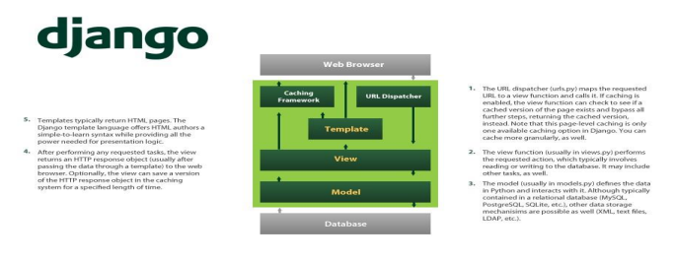

**4.3.1 Advantages of Django:**

* Object- Relational Mapping (ORM) Support Framework Support
* Administration GUI
* Django advocates best practices for SEO
* Development Environment
* Multilingual Support
* Scalability
* Security

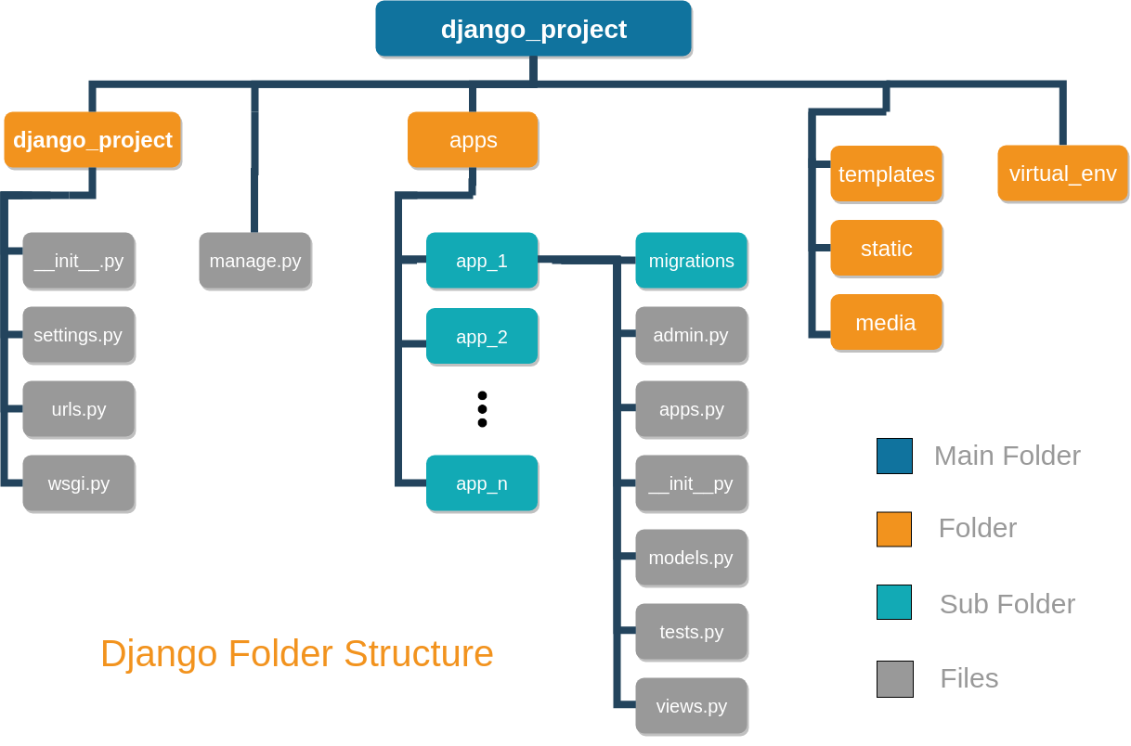

**4.4 Work Done:**

**19**

In this Python training on Django & Flask, I learned how to:

* Use Python libraries for problem solving.
* Create Flask & Django applications.
* Implement database connectivity and performing CRUD operations.
* Create REST API and how to implement GET, POST, PUT & DELETE requests using it.
* Dockerize the application.

**20**

**Chapter-5**

**JavaScript Frameworks: Angular & React**

**5.1 Introduction to JavaScript:**

JavaScript® (often shortened to JS) is a lightweight, interpreted, object-oriented language with first-class functions, and is best known as the scripting language for Web pages, but it’s used in many non-browser environments as well. It is a prototype-based, multi-paradigm scripting language that is dynamic, and supports object-oriented, imperative, and functional programming styles. JavaScript runs on the client side of the web, which can be used to design / program how the web pages behave on the occurrence of an event. JavaScript is an easy to learn and also powerful scripting language, widely used for controlling web page behavior. Contrary to popular misconception, JavaScript is not “Interpreted Java”.

In a nutshell, JavaScript is a dynamic scripting language supporting prototype-based object construction. The basic syntax is intentionally similar to both Java and C++ to reduce the number of new concepts required to learn the language. Language constructs, such as if statements, for and while loops, and switch and try ... catch blocks function the same as in these languages (or nearly so). JavaScript can function as both a procedural and an object-oriented language. Objects are created programmatically in JavaScript, by attaching methods and properties to otherwise empty objects at run time, as opposed to the syntactic class definitions common in compiled languages like C++ and Java. Once an object has been constructed it can be used as a blueprint (or prototype) for creating similar objects. JavaScript’s dynamic capabilities include runtime object construction, variable parameter lists, function variables, dynamic script creation (via eval), object introspection (via for ... in), and source code recovery (JavaScript programs can decompile function bodies back into their source text).

The standards for JavaScript are the ECMAScript Language Specification (ECMA-262) and the ECMAScript Internationalization API specification (ECMA-402). The JavaScript documentation throughout MDN is based on the latest draft versions of ECMA-262 and ECMA402. And in cases where some proposals for new ECMAScript features have already been implemented in browsers, documentation and examples in MDN articles may use some of those new features. Do not confuse JavaScript with the Java programming language. Both “Java” and “JavaScript” are trademarks or registered trademarks of Oracle in the U.S. and other countries.

**21**

However, the two programming languages have very different syntax, semantic, and use.



**5.2 Framework (Angular):**

AngularJS is a JavaScript-based open-source front-end web framework mainly maintained by Google and by a community of individuals and corporations to address many of the challenges encountered in developing single-page applications. It aims to simplify both the development and the testing of such applications by providing a framework for client-side model–view–controller (MVC) and model–view–view model (MVVM) architectures, along with components commonly used in web applications and progressive web applications.

AngularJS is used as the frontend of the MEAN stack, consisting of MongoDB database, Express.js web application server framework, AngularJS itself, and Node.js server runtime environment.

The AngularJS framework is on Long Term Support (“LTS”) until December 31, 2021. After that date Google will no longer update AngularJS to fix security, browser compatibility, or jQuery issues. The Angular team recommends upgrading to Angular (v2+) as the best path forward, but they also provided some other options.

The AngularJS framework works by first reading the Hypertext Markup Language (HTML) page, which has additional custom HTML attributes embedded into it. Angular interprets those attributes as directives to bind input or output parts of the page to a model that is represented by standard JavaScript variables. The values of those JavaScript variables can be manually set within the code, or retrieved from static or dynamic JSON resources. AngularJS is built on the belief that declarative programming should be used to create user interfaces and connect software components, while imperative programming is better suited to defining an

**22**

application’s business logic. The framework adapts and extends traditional HTML to present dynamic content through two-way data-binding that allows for the automatic synchronization of models and views.

AngularJS’s design goals include:

* to decouple DOM manipulation from application logic. The difficulty of this is dramatically affected by the way the code is structured.
* to decouple the client side of an application from the server-side. This allows development work to progress in parallel and allows for reuse of both sides.
* to provide structure for the journey of building an application: from designing the UI, through writing the business logic, to testing.

AngularJS implements the MVC pattern to separate presentation, data, and logic components. Using dependency injection, Angular brings traditionally server-side services, such as view-dependent controllers, to client-side web applications. Consequently, much of the burden on the server can be reduced.



**5.3 Framework (React):**

React (also known as React.js or ReactJS) is a [free and open-source](https://en.wikipedia.org/wiki/Free_and_open-source_software) [front-end](https://en.wikipedia.org/wiki/Front_end_and_back_end) [JavaScript library](https://en.wikipedia.org/wiki/JavaScript_library) for building [user interfaces](https://en.wikipedia.org/wiki/User_interfaces) based on UI components. It is maintained by [Meta](https://en.wikipedia.org/wiki/Meta_Platforms) (formerly Facebook) and a community of individual developers and companies. React can be used as a base in the development of [single-page](https://en.wikipedia.org/wiki/Single-page_application), mobile, or server-rendered applications with frameworks like [Next.js](https://en.wikipedia.org/wiki/Next.js). However, React is only concerned with state management and rendering that state to the [DOM](https://en.wikipedia.org/wiki/Document_Object_Model), so creating React applications usually requires the use of additional libraries for routing, as well as certain client-side functionality.

The following is a rudimentary example of React usage in HTML with [JSX](https://en.wikipedia.org/wiki/React_(JavaScript_library)#JSX) and JavaScript.

**23**

**import** React **from** “react”;

**const** Greeting = () => {

**return** (

<div className=”hello_world”>

<h1> Hello, World! </h1>

</div>

);

};

**export** **default** Greeting;

The Greeting function is a React component that displays the famous introductory ‘’Hello, world”. When displayed in a web browser, the result will be a rendering of:

<**div** class=”hello_world”>

<**h1**>Hello, World!</**h1**>

</**div**>

Another notable feature is the use of a virtual [Document Object Model](https://en.wikipedia.org/wiki/Document_Object_Model), or [virtual DOM](https://tekolio.com/react-virtual-dom-explained-in-simple-words/). React creates an [in-memory](https://en.wikipedia.org/wiki/In-memory_processing) data-structure cache, computes the resulting differences, and then updates the browser’s displayed DOM efficiently.[]](https://en.wikipedia.org/wiki/React_(JavaScript_library)#cite_note-workingwiththebrowser-10) This process is called reconciliation. This allows the programmer to write code as if the entire page is rendered on each change, while the React libraries only render subcomponents that actually change. This selective rendering provides a major performance boost. It saves the effort of recalculating the CSS style, layout for the page and rendering for the entire page.

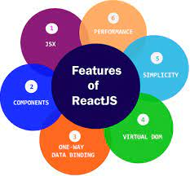

**24**

Lifecycle methods for class-based components use a form of [hooking](https://en.wikipedia.org/wiki/Hooking) that allows the execution of code at set points during a component’s lifetime.

* shouldComponentUpdate allows the developer to prevent unnecessary re-rendering of a component by returning false if a render is not required.
* componentDidMount is called once the component has “mounted” (the component has been created in the user interface, often by associating it with a [DOM](https://en.wikipedia.org/wiki/Document_Object_Model) node). This is commonly used to trigger data loading from a remote source via an [API](https://en.wikipedia.org/wiki/API).
* componentWillUnmount is called immediately before the component is torn down or “unmounted”. This is commonly used to clear resource-demanding dependencies to the component that will not simply be removed with the unmounting of the component
* render is the most important lifecycle method and the only required one in any component. It is usually called every time the component’s state is updated, which should be reflected in the user interface.



**5.4 Work Done:**

In this JavaScript training on Angular & React, I learned how to:

* Create interactive web pages.
* Implement Angular & React applications using different components.
* Display data in tabular format from a GET request consisting of JSON data.
* Render child component from parent component using routing.
* Using HTTP to read & then sort that data in an Angular or React application.

**25**

**Chapter-6**

**Amazon Web Services (AWS)**

**6.1 Introduction to AWS:**

Amazon Web Services, Inc. (AWS) is a subsidiary of [Amazon](https://en.wikipedia.org/wiki/Amazon.com) providing [on-demand](https://en.wikipedia.org/wiki/Software_as_a_service) [cloud computing](https://en.wikipedia.org/wiki/Cloud_computing) [platforms](https://en.wikipedia.org/wiki/Computing_platform) and [APIs](https://en.wikipedia.org/wiki/Application_programming_interface) to individuals, companies, and governments, on a metered pay-as-you-go basis. These cloud computing [web services](https://en.wikipedia.org/wiki/Web_services) provide a variety of basic abstract technical infrastructure and [distributed computing](https://en.wikipedia.org/wiki/Distributed_computing) building blocks and tools. One of these services is [Amazon Elastic Compute Cloud](https://en.wikipedia.org/wiki/Amazon_Elastic_Compute_Cloud) (EC2), which allows users to have at their disposal a [virtual](https://en.wikipedia.org/wiki/Virtualization) [cluster of computers](https://en.wikipedia.org/wiki/Computer_cluster), available all the time, through the Internet. AWS’s virtual computers emulate most of the attributes of a real computer, including hardware CPU’s and GPU’s for processing; local/[RAM](https://en.wikipedia.org/wiki/Random-access_memory) memory; hard-disk/[SSD storage](https://en.wikipedia.org/wiki/Solid-state_drive); a choice of operating systems; networking; and pre-loaded application software such as [web servers](https://en.wikipedia.org/wiki/Web_server), [databases](https://en.wikipedia.org/wiki/Database), and CRM.

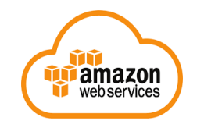

**6.1.1 What is Cloud Computing?**

Cloud computing is the on-demand delivery of IT resources over the Internet with pay-as-you-go pricing. Instead of buying, owning, and maintaining physical data centers and servers, you can access technology services, such as computing power, storage, and databases, on an as-needed basis from a cloud provider like Amazon Web Services (AWS).

In 2006, Amazon Web Services (AWS) began offering IT infrastructure services to businesses in the form of web services – now commonly known as cloud computing. One of the key benefits of cloud computing is the opportunity to replace up-front capital infrastructure expenses with low variable costs that scale with your business. With the Cloud, businesses no longer need to plan for and procure servers and other IT infrastructure weeks or months in advance. Instead, they can instantly spin up hundreds or thousands of servers in minutes and

**26**

deliver results faster.

Today, Amazon Web Services provides a highly reliable, scalable, low-cost infrastructure platform in the cloud that powers hundreds of thousands of businesses in 190 countries around the world. With data center locations in the U.S., Europe, Brazil, Singapore, Japan, and Australia, customers across all industries are taking advantage of it.

**6.2 Benefits of AWS:**

Some benefits of AWS are as follows:

* **Low Cost:**

AWS offers low, pay-as-you-go pricing with no up-front expenses or long-term commitments. We are able to build and manage a global infrastructure at scale, and pass the cost saving benefits onto you in the form of lower prices. With the efficiencies of our scale and expertise, we have been able to lower our prices on 15 different occasions over the past four years.

* **Agility and Instant Elasticity:**

AWS provides a massive global cloud infrastructure that allows you to quickly innovate, experiment and iterate. Instead of waiting weeks or months for hardware, you can instantly deploy new applications, instantly scale up as your workload grows, and instantly scale down based on demand. Whether you need one virtual server or thousands, whether you need them for a few hours or 24/7, you still only pay for what you use.

* **Open and Flexible:**

AWS is a language and operating system agnostic platform. You choose the development platform or programming model that makes the most sense for your business. You can choose which services you use, one or several, and choose how you use them. This flexibility allows you to focus on innovation, not infrastructure.

* **Secure:**

AWS is a secure, durable technology platform with industry-recognized certifications and audits: PCI DSS Level 1, ISO 27001, FISMA Moderate, FedRAMP, HIPAA, and

**27**

SOC 1 (formerly referred to as SAS 70 and/or SSAE 16) and SOC 2 audit reports. Our

services and data centers 62 have multiple layers of operational and physical security to ensure the integrity and safety of your data.

* **Solutions:**

The AWS cloud computing platform provides the flexibility to launch your application regardless of your use case or industry. Learn more about popular solutions customers are running on AWS. Use reliable, on-demand infrastructure to power your applications, from hosted internal applications to SaaS offerings.

* **Websites:**

Satisfy your dynamic web hosting needs with AWS’s scalable infrastructure platform.

* **Backup and Storage:**

Store data and build dependable backup solutions using AWS’s inexpensive data storage services.

* **Enterprise IT:**

Host internal- or external-facing IT applications in AWS’s secure environment.

* **Content Delivery:**

Quickly and easily distribute content to end users worldwide, with low costs and high data transfer speeds.

* **Databases:**

Take advantage of a variety of scalable database solutions, from hosted enterprise database software or non-relational database solutions.

**6.3 Most Used AWS Services:**

* **Amazon S3 (Simple Storage Service):**

Amazon S3 is listed top in the AWS services list – because, storing and retrieving the data plays a prominent role in cloud computing. So, AWS offers a wonderful service

**28**

called Amazon Simple Storage Service or Amazon S3 to store and retrieve data from

the cloud. S3 allows the user to store, upload, retrieve large files up to 5 TB from the

cloud. It is a scalable, low-cost and high-speed web-based service designed for archival

and online backup of application programs and data. Using S3, the user can access the same system that Amazon uses to run its website. Users have control over the public or private accessibility of the data.



* **Amazon EC2 (Elastic Compute Cloud):**

Amazon EC2 provides scalable computing capacity in the AWS cloud. Using Amazon EC2, you can develop and deploy applications quickly and effectively for a low cost. And also, you can use Amazon EC2 to launch virtual servers according to your requirements.



* **AWS Lambda:**

Amazon Lambda is a service that allows the user to run code without any server. Amazon Lambda executes the code only when the user needed and scales automatically. Users pay only for the compute time, no need to charge when your code is not running. This service supports the code written in Node.js, Java, Python, and languages supported by Amazon Linux.

**29**



* **Amazon Glacier:**

Amazon Glacier is one of the most important services provided by AWS. The Glacier is an online web storage service that provides you with low cost and effective storage with security features for archival and data backup. With Glacier, you can store the information effectively for months, years, or even decades.



* **Amazon SNS (Simple Notification Service):**

Amazon SNS is a web service provided by the AWS. SNS stands for Simple Notification Service, and it manages and delivers the messages or notifications to the users and clients from any cloud platform. In SNS, there are two types of clients, subscribers, and publishers. Publishers produce and send a message to the subscriber instance through the communication channels.

Subscribers receive notification from the publisher over one of the supported protocols such as Amazon SQS, HTTP, and Lambda, etc. Amazon SNS automatically triggers the service and sends an email with a message that “your EC2 instance is growing” when you are using Auto Scaling. Amazon SNS automatically triggers the service and sends an email with a message that “your EC2 instance is growing” when you are using Auto Scaling.



**30**

* **Amazon CloudFront:**

To Know how fast your website is working, you can use the CloudFront service. It speeds up the sharing of your dynamic and static web content such as .css, .html and image files to your users. It securely delivers your images, videos, data and applications to users and clients with high transfer speed and low latency, all within a developer-friendly environment.



* **Amazon EBS (Elastic Block Store):**

EBS is an Amazon service, which is used to store persistent data, and it is block-level storage to use EC2 instances. You can use EBS service, to move the data from one instance to another instance without losing the stored data at EBS. You can mount multiple volumes on the same instance, but each volume can be attached to a single instance at a time.



* **Amazon Kinesis:**

Are you worried about how to deal with the large volume of data? AWS is offering Amazon Kinesis service to handle big data in real-time. It allows developers to take any large volume of data from any source that can run on EC2 instance. It stores, capture and processes the data from large distributed streams like social media feeds and log events. After completion of processing the data, it distributes the data to the consumers simultaneously.



**31**

* **Amazon VPC (Virtual Private Cloud):**

Is my data secure in the AWS Cloud? Yes, your information is secure in the AWS cloud with the Amazon VPC service. Using the Virtual Private Network, the data is secured because only authorized people can view the data. So, the information is not exposed to outside people or networks.



* **Amazon SQS (Simple Query Service):**

Amazon SQS stands for Simple Queue Service, and it manages the message queue service. Using this service, you can move the data or message from one application to another even though it is not in the running or active state. SQS sends messages between multiple services, including S3, DynamoDB, EC2 Instance, and also it uses the Java message queue service to deliver the information. The maximum visibility timeout of a message is 12 hours in the SQS queue.



* **Amazon Elastic Beanstalk:**

Developers can easily deploy the services and web applications developed with .NET, Java, PHP, Python and more without providing any infrastructure. A number of cloud clients, including Amazon Web Services, Microsoft Azure, offer development tools to make the process easy and simple.

**32**



* **AWS DynamoDB:**

It is a fully managed NoSQL database service that supports document data structures and key values that are offered by Amazon.com. DynamoDB allows you to create the database tables so that you can retrieve and store any format of data. It controls the data traffic over multiple servers and maintains the performance of the tables.



* **Amazon RDS (Relational Database Service):**

It is a fully SQL database cloud service that allows users to operate and create relational databases. RDS can manage from any AWS Management Console. Using RDS, you can access files and databases from anywhere in a highly scalable and cost-effective way.



* **Amazon ElastiCache:**

It is a memory cache system service on the cloud and supports Redis and Memcached. ElasticCache improves the memory performance by CPU Intensive Queries and Caching I/O queries in memory for quick results. It integrates with all other services, and you can manage from both user API and management console. Using Virtual Private

**33**

Cloud, you can run the ElastiCache cluster in Amazon.



* **Amazon Redshift:**

Amazon Redshift is a fully managed data warehouse service in the cloud. Redshift gives you to access structured data from the existing SQL, ODBC, and JDBC. When you are executing the large query, it divides the query into small parts and assigns them among the multiple nodes for parallel operations. According to the user requirements, it controls the nodes in the Redshift.



**6.4 Work Done:**

In this Cloud Computing training on AWS, I learned how to:

* Implement IAM policies with JSON & define permissions.
* Create a VPC & configuring it using security groups.
* Run Windows & Linux virtual machines in cloud using Amazon EC2.
* Use serverless computing with the help of AWS Lambda.
* Implement S3 to store data as objects.

**34**

**Chapter-7**

**Project Shadowing**

**7.1 What is Project Shadowing?**

Project shadowing is a useful way to learn about a particular job of interest.

Each project-shadowing experience can be different. However, you typically will follow an employee and observe them partaking in their day-to-day work. They might ask you to help with certain tasks, as well.

Depending on how long you shadow an employee, you might even learn skills critical to the job. Some employees will give you opportunities to ask questions throughout the day or at the end of the experience.

**7.2 How Shadowing Works?**

Project shadowing can be done as part of a formal program organized by a high school or university, or it can be scheduled informally.

You can usually find a formal project shadowing program through your high school guidance counsellor or your [college’s career services office](https://www.thebalancecareers.com/college-job-search-guide-2060548). Schools might also have a list of [alumni](https://www.thebalancecareers.com/how-to-use-your-alumni-network-in-a-job-search-2059887) who are willing to let students job shadow.

If you cannot find a formal program through your school, you might meet with a [career counsellor](https://www.thebalancecareers.com/how-to-choose-a-career-counselor-or-coach-2059777) for help finding a shadowing opportunity or reach out to people in your [network](https://www.thebalancecareers.com/top-career-networking-tips-for-college-students-2062581). Some large organizations and government agencies also offer job shadowing programs to students.

If you’re thinking of [changing careers](https://www.thebalancecareers.com/successful-career-change-2058452) then job shadowing might be a good idea. Start by meeting with a career counselor or get in touch with your college career services office if it provides assistance to alumni. Or, you can just reach out to professional contacts, friends, and family to see if you can spend a day with them in the office.

**7.3 Benefits of Shadowing:**

**35**

Project shadowing can be useful in a number of ways, including helping you decide whether or not you’d enjoy and feel passionate about a job. You’ll also find out if your skills match the career field of interest and whether your[skills](https://www.thebalancecareers.com/hard-skills-vs-soft-skills-2063780) from school and other jobs might translate to this job.

Because project shadowing is a short-term experience, it can be a great way to decide whether or not you want to pursue a particular career before applying for jobs or internships.

Project shadowing also helps you [develop contacts](https://www.thebalancecareers.com/building-growing-and-maintaining-a-professional-network-525834) in your career field of interest. When shadowing someone who is competent in their field, you have the opportunity to gain a useful resource as you begin to seek and apply for jobs and internships.

**7.4 My Experience:**

After 1-month of training, mentors were assigned and project shadowing was started. Mentors are those individuals who are working in the company over a descent period. This allowed us to closely monitor how to deal with real-life projects, with proper guidance from our mentor. The successful completion of this phase will lead to the assigning of real-life projects.

This phase continued for around 4 weeks and afterwards, projects were assigned.

**36**

**Chapter-8**

**Project Phase: Consultpedia**

**8.1 Overview:**

After 4-weeks of project-shadowing, projects were assigned based on the performance in training & preferred tech-stack of every individual.

My preferred tech-stack was **JAVA (Back-end) + Angular (Front-end) + AWS (Deployment)**, so I was assigned a project based on these technologies.

**8.2 Project Details:**

* **Project Title** 🡪 Consultpedia
* **Broad Area** 🡪 Web Development + Cloud Computing
* **Project Start Date** 🡪 01/03/2022
* **Project End Date** 🡪 15/04/2022
* **Project Team** 🡪 Epimoní̱s

**8.3 Project Introduction:**

E-commerce is fast gaining ground as an accepted and used business paradigm. More and more business houses are implementing web sites providing functionality for performing commercial transactions over the web. It is reasonable to say that the process of shopping on the web is becoming commonplace.

**Consultpedia** strives to provide solutions to develop and transfer easy and efficient way in the digital age and to help reducing the human pressure and time, to help support shop collections, the digital initiatives, and external partner institution digital projects. It provides services that include the digitization of analog objects, metadata management, cloud security, and deployment and access of digital collections. Consultpedia is a web application written for all

**37**

operating systems, designed to help users maintain and organize shop virtually. This software is easy to use for both beginners and advanced users. It features familiar and well throughout an attractive user interface, combined with strong searching Insertion and reporting capabilities. The order generation facility of shop system helps to get a good idea of which are the various items brought by the customers & also makes possible for the customers to get the product easily.

There are three actors in our application- customer, employee and manager. Customers can register if he is a new user and doesn’t have an account, if already registered then he can directly login to the web application using the registered email id & password and then he can order products, checkout cart and view orders. Employees can add/remove products, maintain customer’s information, view & update stocks as well as can cancel/confirm the customer orders. Manager is like the admin. He manages all the details of the customer & employee.

**8.4 Project Objectives:**

The objective of this project is to develop a general-purpose e-commerce website where any product (such as books, food items, drinks, clothes & electronic items) can be bought from the comfort of home through the Internet. An online website is like a virtual store on the Internet where customers can browse the catalog and select products of interest. The selected items may be collected in a shopping cart. At checkout time, the items in the shopping cart will be presented as an order. Customers can also remove the items from the cart & even cancel it, accordingly.

Usually, the customer will be asked to fill or select a billing address, a shipping address, a shipping option, and payment information such as a credit card number. An email notification is sent to the customer as soon as the order is placed.

Some other objectives of the project are:

* To provide a secure system application in terms of information retrieval.
* To create a user-friendly interface, which will help users to buy products easily.
* To properly maintain information about the employees, customers, orders and product stocks.

**38**

* To have a Manager Role which can perform various operations to maintain proper functionality and transparency.
* To help in decision making efficiently.
* To provide a systematic product inventory.
* To reliably deploy the application on cloud, so that it is available globally & works well on all operating systems.
* 24 * 7 availability of the website with reliable database.

**8.5 Features of Project:**

* User-friendly access
* PostgreSQL provides object relational architecture as well as many more data types.
* Cloud Deployment suits it for high volumes of both reads & writes.
* Access control is secured because of Cloud Security.
* Complete details of products from stock to prices.
* Provides 3 different types of users for accessing, i.e., Customer, Employee & Manager.

**8.6 Proposed System:**

* Our E-commerce website will allow the people to buy the products easily, User friendly interface.
* All the products which will be listed on the website are approved by AGMARK, ISI, FPO Mark, The green & brown dot, India Organic Certification & Ecomark.
* Each employee will be properly approved by the manager, otherwise he cannot login and sell medicines.
* Manager can perform various operations such approve/reject employee, update employer/customer information, can see order details to maintain proper functionality and transparency.
* Cash on Delivery feature also available on our website.
* Payment Gateway integration for online transaction.

**39**

* 24 * 7 availability of the website with reliable database.

**8.7 Scope:**

* A secure system application in terms of information retrieval.
* A user-friendly website interface, which will help users to buy products easily.
* Data Security as none of the users’ data will be shared.
* Taking only necessary information from users while registering on website (no extra information).
* Proper Validation check while entering information (at the time of registration, login or while changing any other information) which will restrict users’ from entering any false information.
* Proper authorization of employees by manager. So, only valid employees can add products as this issue is concerned with people.
* Proper functionality and transparency of the website is maintained, as Manager can perform various operations.
* Customers can choose to do payment either through Cash on Delivery or Online Transaction.

**8.8 Feasibility Study**

* **Financial Feasibility**

Being a website, Consultpedia will have an associated hosting cost on AWS. Since the system doesn’t consist of any multimedia data transfer (except the images of medicine), bandwidth required for the operation of this application is very low. The system will follow the standard software engineering practices. No cost will be charged from the potential customers. From these it’s clear that our project is financially feasible.

* **Technical Feasibility**

Consultpedia is an e-commerce website. The main technologies and tools that are associated with it are:

* **Front End:**

Angular Framework (JavaScript)

* **Backend:**

**40**

Spring-Boot Framework (Java)

* **Database:**

PostgreSQL

* **Software Used:**

Visual Studio Code, IntelliJ IDEA, JIRA

* **Deployment Tools:**

AWS Elastic Beanstalk, AWS Simple Storage Service (S3), AWS Relational Database Service (RDS)

Each of the technologies are freely available and the technical skills required are manageable. Time limitations of the product development and the ease of implementing using these technologies are synchronized. From these it’s clear that our project is technically feasible.

* **Resource and Time Feasibility:**

Resources that are required for our project includes:

* Programming device (Laptop)
* Programming tools (freely available)
* Programming individuals

So, it’s clear that our project has the required resource feasibility.

* **Risk Feasibility:**

Risk feasibility can be discussed under several contexts:

* + **Risk associated with size:**

As the system, doesn’t contain any multimedia aspect (except the images of medicine), the file sizes and the complete project size will not exceed 500MB.

* + **Business impact risks:**

The project Consultpedia will have several deadlines and deliverables that are scheduled successively.

* + **Process issue risks:**

Consultpedia will follow the Agile software development process. This provides the flexibility to accommodate changing software requirements of it.

**41**

* + **Development environment risks:**

Software Project Management tools are available for free which will help in analyzing & designing, compiling & code-generation, testing, database management.

* + **Technology risks:**

All the technologies are very well established and old enough (but not obsolete).

* + **Technical issue risks:**

Software code will be freely available and the code documentation will be provided.

* **Social/Legal Feasibility:**

Consultpedia uses freely available development tools, and provide the system as an open-source system. Only the maintenance cost will be charged from potential customers. Java packages, servers, Angular libraries, AWS services that are used in this system are free & open-source.

**8.9 Technologies Used:**

* **Backend** 🡪 Java/Spring-Boot
* **Frontend** 🡪 Angular
* **Database** 🡪 PostgreSQL
* **Deployment** 🡪 AWS Relational Database Service (RDS), AWS Elastic Beanstalk &

AWS Simple Storage Service (S3)

**42**

**Chapter 9**

**Requirement Analysis**

**9.1 Functional Requirements**

* Customer can register on the website.
* It is necessary that the manager must approve employee for the first time and only after a successful approval, he will be able to login to the website.
* Manager can login and see the details about the Employees, Customers, Stocks and Orders.
* Manager, Employee and Customer can forget and change password.
* Manager can update & delete customer information, employee information and orders information.
* Employee can add products, view & update stock, cancel/finish customer orders.
* Customer can order products, make payments, view past orders.

**9.2 Non-Functional Requirements**

1. **Usability:**

The website has an easy-to-use interface to enhance customers experience and hence users can smoothly crawl over the webpages.

1. **Reliability:**

The system produces accurate results and hence user can rely on the data being showed to them.

1. **Availability:**

As it is an online platform which will be available to users 24 hours a day, 7 days a week (24 * 7).

1. **Performance**:

The system will respond to user’s action and display results immediately and takes just fraction of seconds to switch between multiple web pages.

1. **Security:**

The system must prevent Customers from changing the price of products other than

**43**

ordering and making payments. It must also prevent Employees from interfering other employees.

Only Manager can delete customer, employee and maintain both employee and customer information. Only employee can view stock and add products.

User’s data is never shared with anyone. Also, the payment information (if any) is completely secured.

1. **Design Constraints:**

The system shall provide an easy-to-use Web User Interface.

**9.3 Data Requirements**

The project requires data like employee & customer information which will be managed by the manager, and it also requires product data which will be shown to customers/users which will be managed by the verified & approved employees.

**9.4 Requirement Validation**

Requirements validation is the process of checking the requirements defined for development, define system that the customer really wants. So, to validate requirements we had performed different types of check through defined approaches in Software Requirements Specification. This requirement validation has helped us to find issue related to requirements at the initial phase of development as the error may increase and excessive rework need to be done when these errors are detected later in the development process.

* **Test Case Generation:**

All the requirements mentioned are testable. The test cases are easy to design and test as the requirements are easy to implement.

* **Requirements Reviews:**

We have carefully reviewed and analyzed the SRS document to check error and ambiguity.

* **Walk-through:**

Before reaching to the conclusion, we had properly analyzed and checked whether the idea is feasible or not, performed feasibility analysis. Furthermore, we had also done

**44**

research in this field to understand the requirements more clearly.

**9.5 Hardware Requirements**

* **RAM:** Minimum 4 GB

Recommended: 8 GB

* **Processor:** Minimum x32-bit

Recommended: x64-bit, 2.8 GHz or faster processor

* **OS:** Windows 🡪 7 or later / MAC 🡪 OS X v10.7 or higher / Linux 🡪 Ubuntu
* **Monitor Resolution:** 1280 x 800

Recommended: 1920 x 1080

* **Internet Connection:** Required

**45**

**Chapter-10**

**System Design**

**10.1 Database Design:**

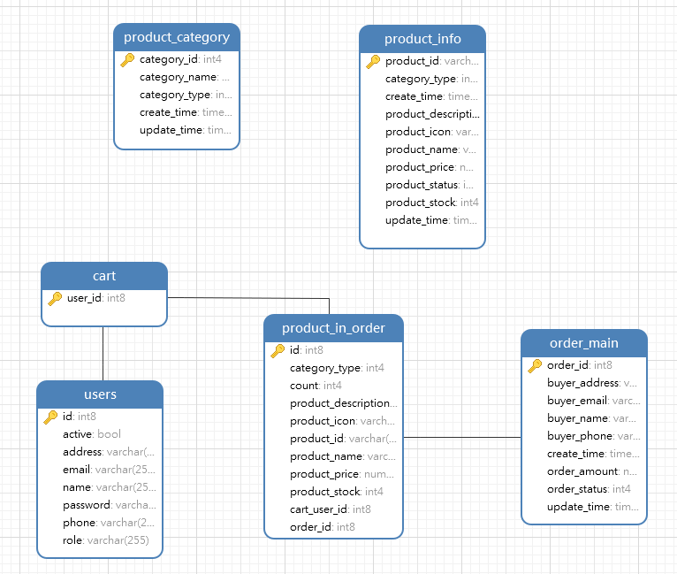

**46**

**10.2 Project Diagrams:**

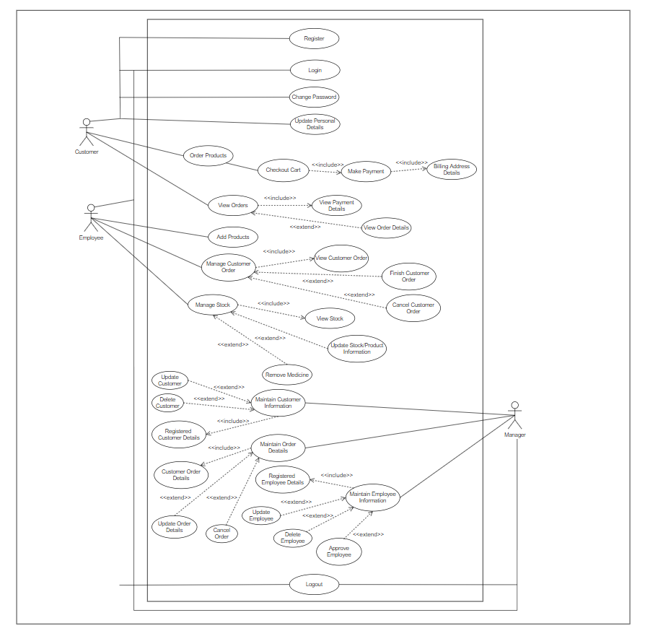**10.2.1 Use-Case Diagram:**

**47**

**10.2.2 Activity Diagram:**

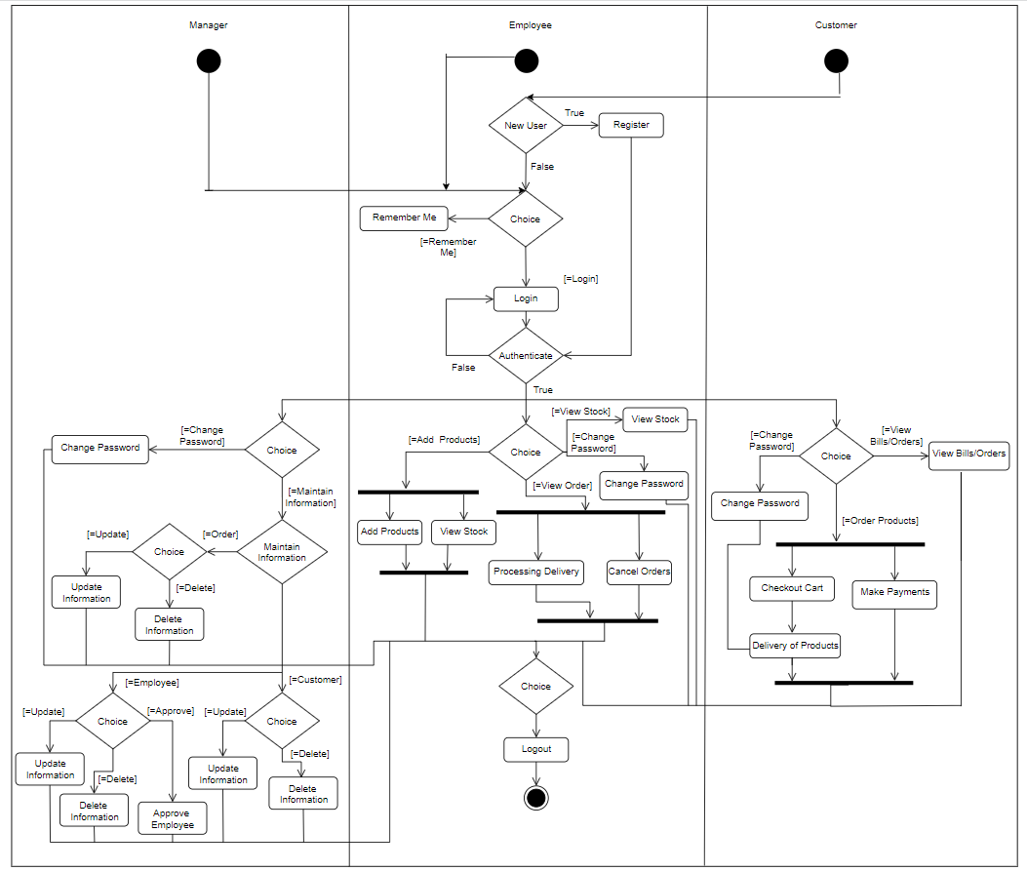**48**

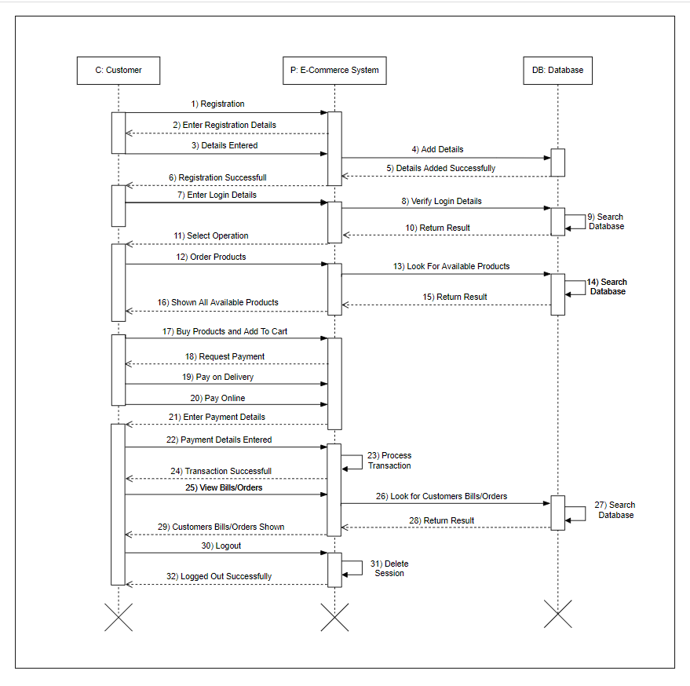**10.2.3 Sequence Diagram (Customer):**

**49**

**10.2.4 Collaboration Diagram (Customer):**

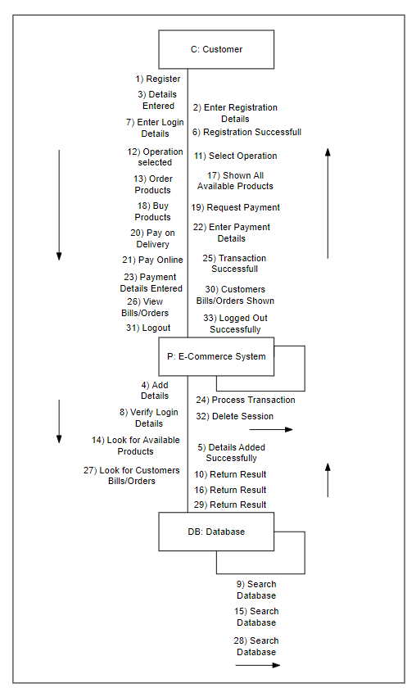

**50**

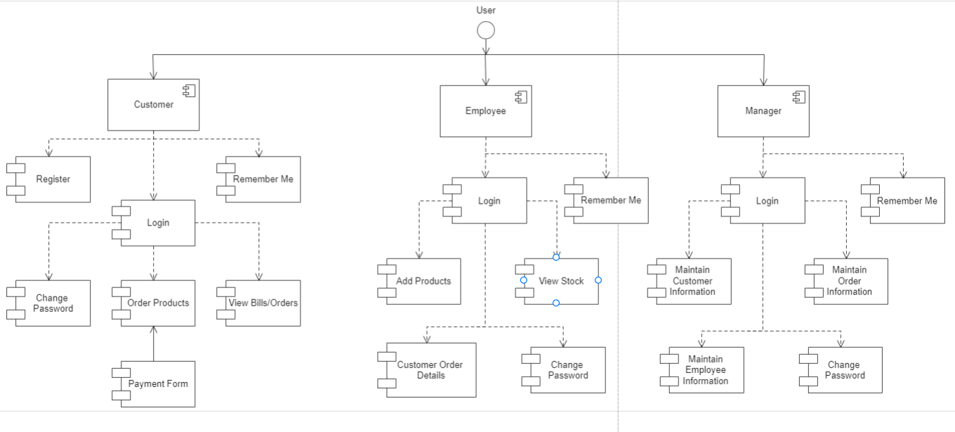**10.2.5 Component Diagram:**

**51**

**10.2.6 Deployment Diagram**

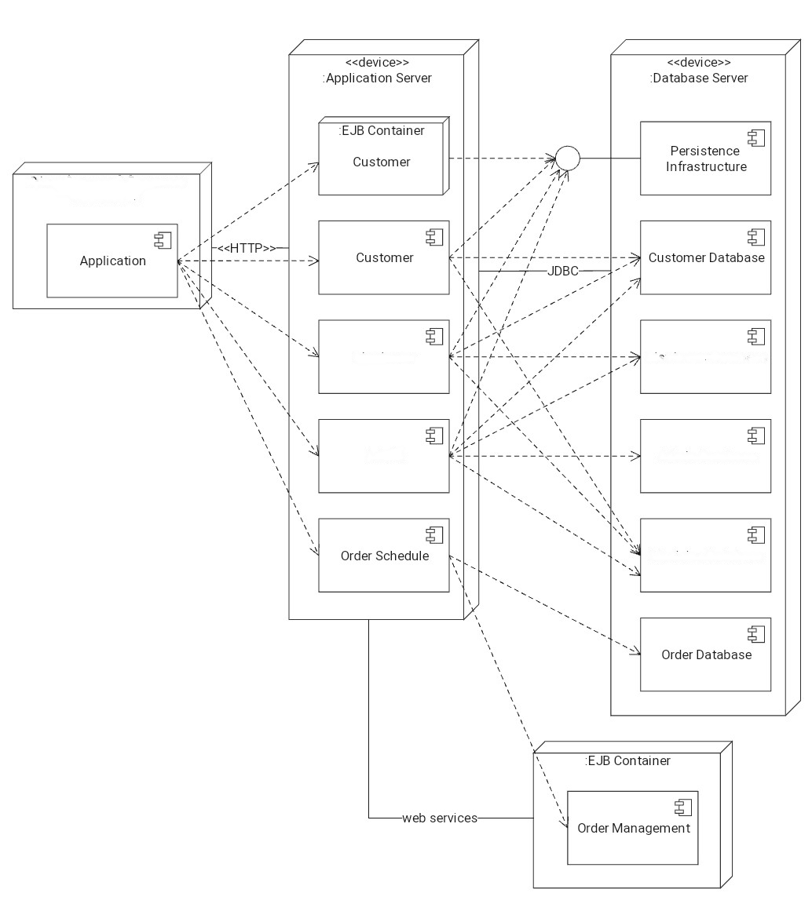

Client Browser E-Commerce Application

Employee Database

Employee

Manager Database

Manager

Product Database

**52**

**Chapter-11**

**Testing**

**11.1 Testing Methods Applied:**

The various types of testing which we have applied on our project are:

1. **Unit Testing:**

After creating every module, we have tested each module individually whether it is working with proper functionality or not. Are there any bugs or problem in an individual module?

1. **Integration Testing:**

After completion of project, we have integrated all the modules together logically and tested as a group to check after combining whether the project functionalities are working properly or not.

1. **Black Box Testing:**

After making project and integrating all the modules together. We have applied black box testing to check whether all the functionalities are working correctly or not. The users who don’t have technical/programming knowledge can also perform this testing.

1. **White Box Testing:**

White Box Testing is a way of testing the software in which the tester has knowledge about the internal structure or the code or the program of the software. It is mostly done by software developers. Knowledge of implementation of the project is very important.

1. **Regression Testing:**

We have also applied regression testing at places where we have made some changes in the module or where we have added any new functionality. We have applied this testing to check that whether by making these changes, our project old functionalities are working properly or not. **“Are there any issues in the project old functionalities after making the changes in the project?”** If there is any issue present or by making changes in one module other module is also getting affected, then we have tried to solve that issue.

**53**

**11.2 Test Cases:**

**1. Sign In**

* **Manager Sign in:**

|  |  |  |  |  |  |
| --- | --- | --- | --- | --- | --- |
| **Test Case**  **ID** | **Test** | **Expected**  **Input** | **Expected Output** | **Actual Result** | **Status** |
| 1. | To Sign in into the Manager Home Page | Email,  Password | Login Successfully | Signed in Successfully (Manager Home Page) | Pass |
| 2. | Trying to Sign in with wrong Email/Password | Email, Password | Not able to Sign in | Not able to Sign in | Pass |

* **Employee Sign in:**

|  |  |  |  |  |  |
| --- | --- | --- | --- | --- | --- |
| **Test Case**  **ID** | **Test** | **Expected**  **Input** | **Expected Output** | **Actual Result** | **Status** |
| 1. | To Sign in into the Employee Home Page | Email,  Password | Sign in Successfully | Signed in Successfully (Employee Home Page) | Pass |
| 2. | Trying to Sign in with wrong Email/Password | Email, Password | Not able to Sign in | Not able to Sign in | Pass |

* **Customer Sign in:**

|  |  |  |  |  |  |
| --- | --- | --- | --- | --- | --- |
| **Test Case**  **ID** | **Test** | **Expected**  **Input** | **Expected Output** | **Actual Result** | **Status** |
| 1. | To Sign in into the Customer Home Page | Email,  Password | Sign in Successfully | Signed in Successfully (Customer Home Page) | Pass |
| 2. | Trying to Sign in with wrong Email/Password | Email, Password | Not able to Sign in | Not able to Sign in | Pass |

**54**

**2. Change Password**

|  |  |  |  |  |  |
| --- | --- | --- | --- | --- | --- |
| **Test Case**  **ID** | **Test** | **Expected**  **Input** | **Expected Output** | **Actual Result** | **Status** |
| 1. | Entering Correct Old Password | Old Password, New Password | Password Changed Successfully | Password Changed Successfully | Pass |
| 2. | Entering Wrong Old Password | Old Password, New Password | Password Not Changed Successfully | Password Not Changed Successfully | Pass |

**3. Managing Customer & Orders Administration (Manager, Employee)**

* **Customer Administration**

|  |  |  |  |  |  |
| --- | --- | --- | --- | --- | --- |
| **Test Case**  **ID** | **Test** | **Expected**  **Input** | **Expected Output** | **Actual Result** | **Status** |
| 1. | Deleting Customer, already registered with the system | Email | Customer Deleted Successfully | Customer Deleted Successfully | Pass |
| 2. | Deleting Customer not registered with the system | Email | Customer Not Deleted Successfully. Please, Enter Correct Email ID | Customer Not Deleted Successfully. Please, Enter Correct Email ID | Pass |
| 3 | Update Customer Details | Email,  Password,  First Name,  Last Name,  Address,  Mobile No.,  D.O.B. | Customer Details Updated Successfully | Customer Details Updated Successfully | Pass |

**55**

* **Orders Administration**

|  |  |  |  |  |  |
| --- | --- | --- | --- | --- | --- |
| **Test Case**  **ID** | **Test** | **Expected**  **Input** | **Expected Output** | **Actual Result** | **Status** |
| 1. | Cancel Order | Email | Customer Order Cancelled Successfully | Customer Order Cancelled Successfully | Pass |
| 2. | Finish Order | Email | Customer Order Finished Successfully | Customer Order Finished Successfully | Pass |

**4. Customer Registration**

|  |  |  |  |  |  |
| --- | --- | --- | --- | --- | --- |
| **Test Case**  **ID** | **Test** | **Expected**  **Input** | **Expected Output** | **Actual Result** | **Status** |
| 1. | To Register Customer | Email, Name,  Password,  Phone No, Address | Customer Registered Successfully. | Customer Registered Successfully. | Pass |

**5. Employee Adding Product**

|  |  |  |  |  |  |
| --- | --- | --- | --- | --- | --- |
| **Test Case**  **ID** | **Test** | **Expected**  **Input** | **Expected Output** | **Actual Result** | **Status** |
| 1. | Add Product | Photo,  Code, Name,  Type, Description,  Price, Stock,  Status | Product Added Successfully | Product Added Successfully | Pass |
| 2. | Update Product | Photo,  Code, Name,  Type, Description,  Price, Stock,  Status | Product Updated Successfully | Product Updated Successfully | Pass |

**56**

**6. Buy Product**

|  |  |  |  |  |  |
| --- | --- | --- | --- | --- | --- |
| **Test Case**  **ID** | **Test** | **Expected**  **Input** | **Expected Output** | **Actual Result** | **Status** |
| 1. | Buying Product | Click on Get It Button & Add to Cart | Asking for Quantity and Payment Details | Asking for Quantity and Payment Details | Pass |

**7. Sign out**

* **Manager Sign out:**

|  |  |  |  |  |  |
| --- | --- | --- | --- | --- | --- |
| **Test case**  **Id** | **Test** | **Expected**  **Input** | **Expected output** | **Actual result** | **Status** |
| 1. | To Sign out from Manager Page | Click on Sign Out button | Signed out Successfully | Signed out Successfully | Pass |

* **Employee Sign out:**

|  |  |  |  |  |  |
| --- | --- | --- | --- | --- | --- |
| **Test case**  **Id** | **Test** | **Expected**  **Input** | **Expected output** | **Actual result** | **Status** |
| 1. | To Sign out from Employee Page | Click on Sign Out button | Signed out Successfully | Signed out Successfully | Pass |

* **Customer Sign out:**

|  |  |  |  |  |  |
| --- | --- | --- | --- | --- | --- |
| **Test case**  **Id** | **Test** | **Expected**  **Input** | **Expected output** | **Actual result** | **Status** |
| 1. | To Sign out from Customer Page | Click on Sign Out button | Signed out Successfully | Signed out Successfully | Pass |

**57**

**Chapter-12**

**Project Snapshots**

**Home Page**

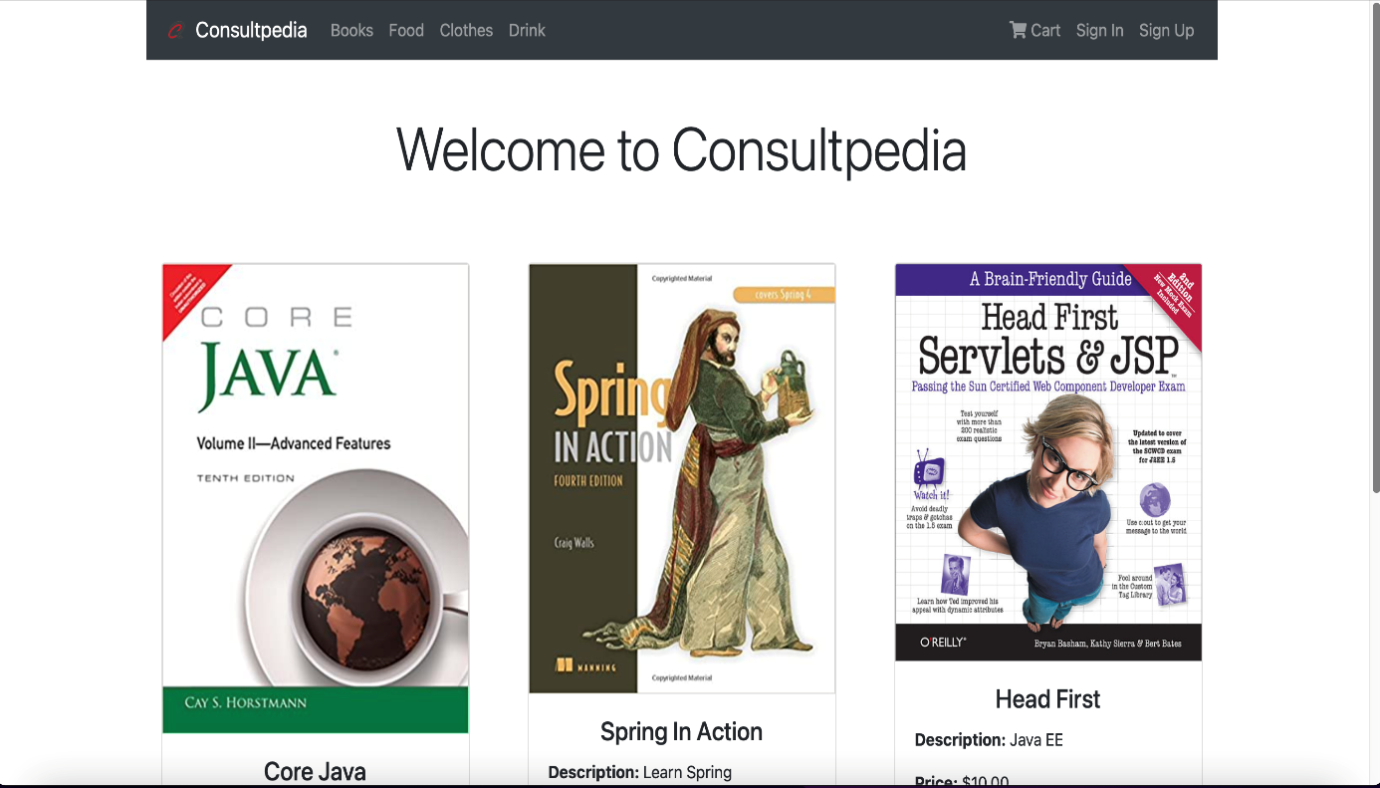

**Clothes Page**

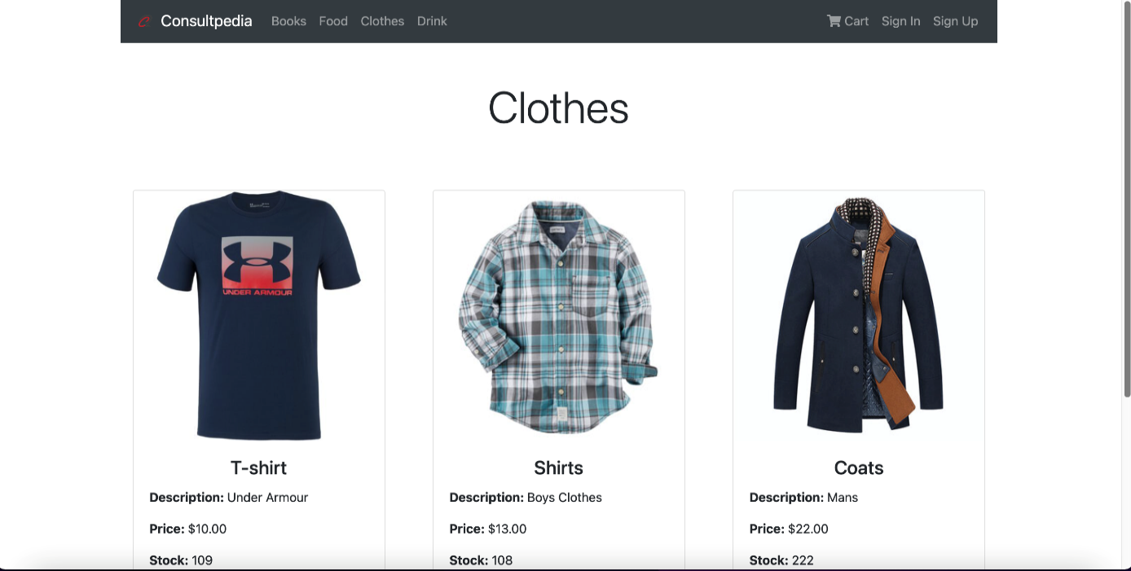

**58**

**Drinks Page**

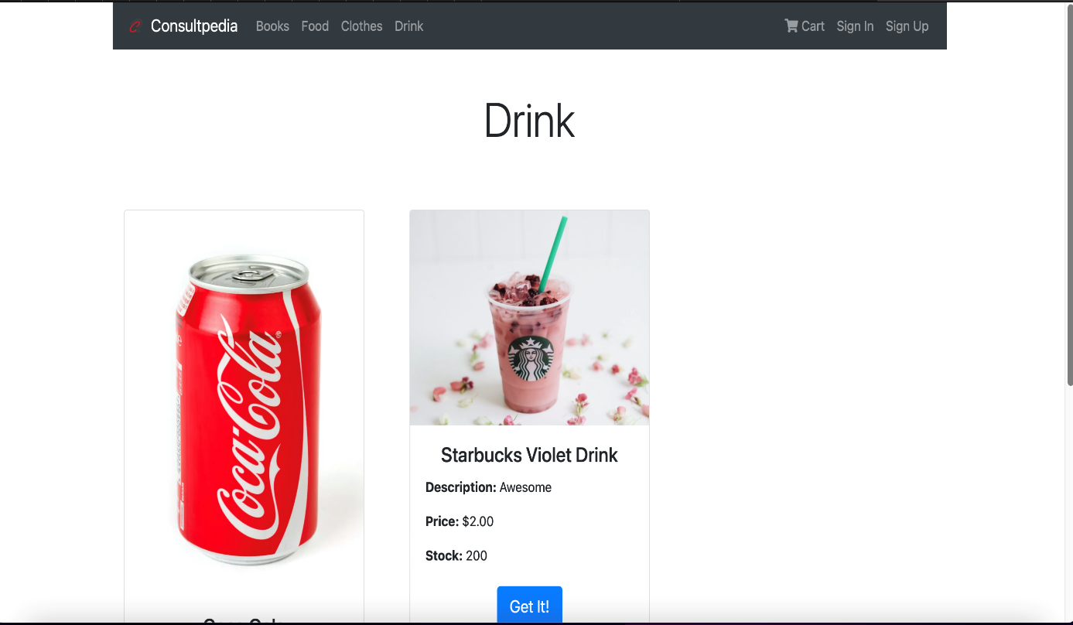

**Sign-Up Page**

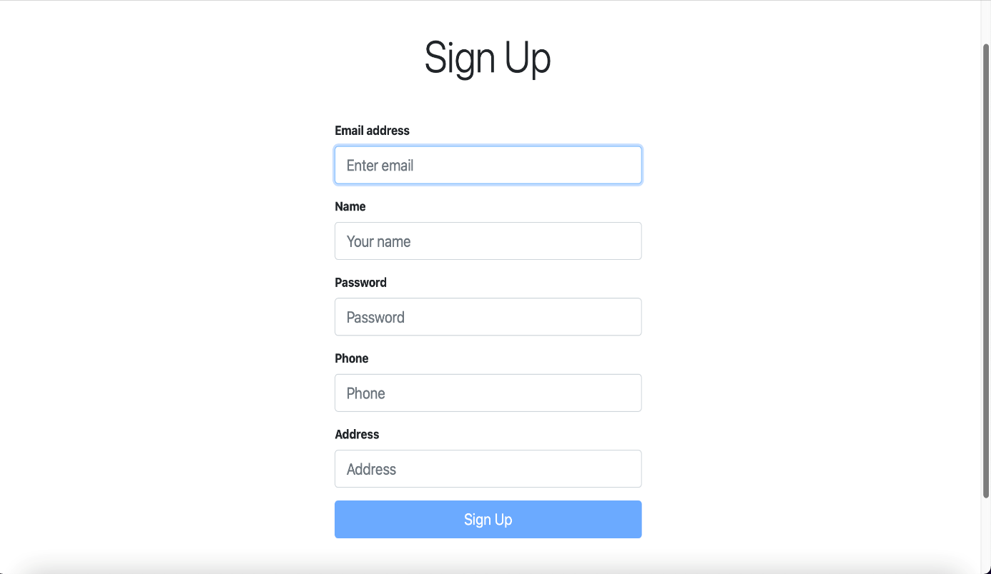

**59**

**Sign-In Page**

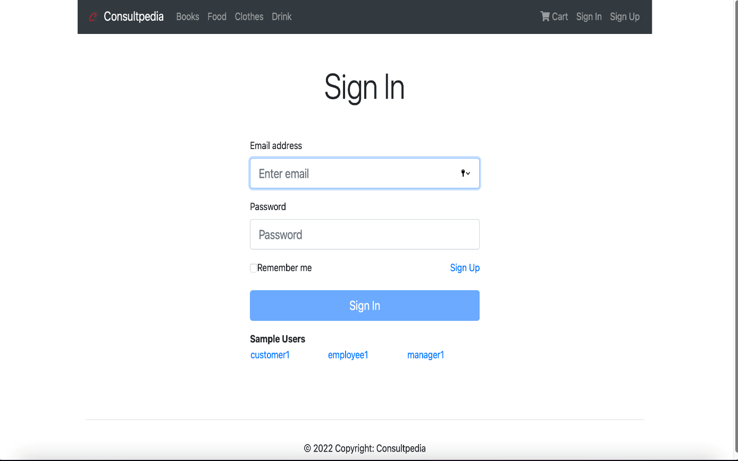

**Product Detail Page**

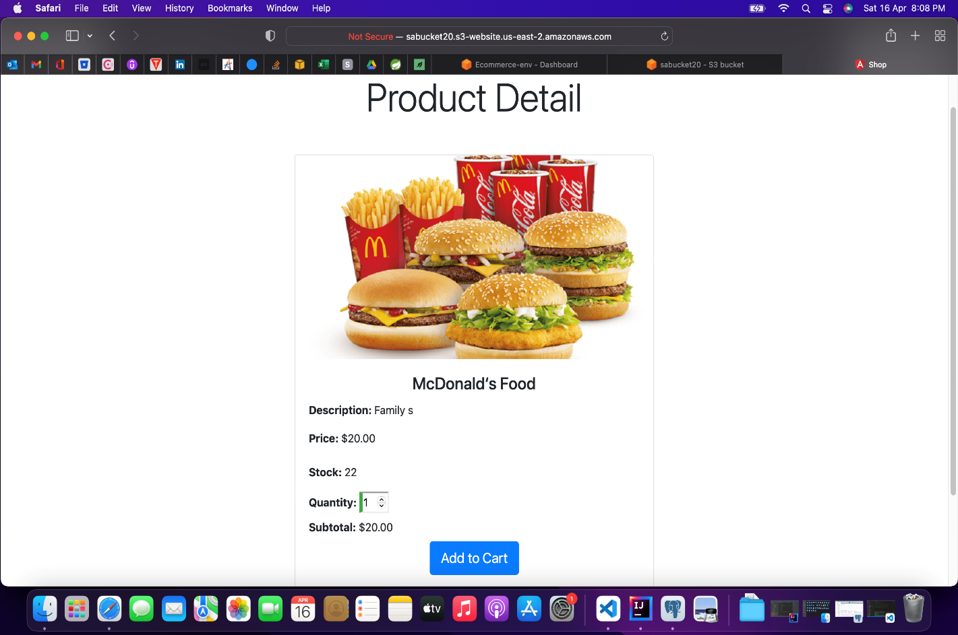

**60**

**Cart Page**

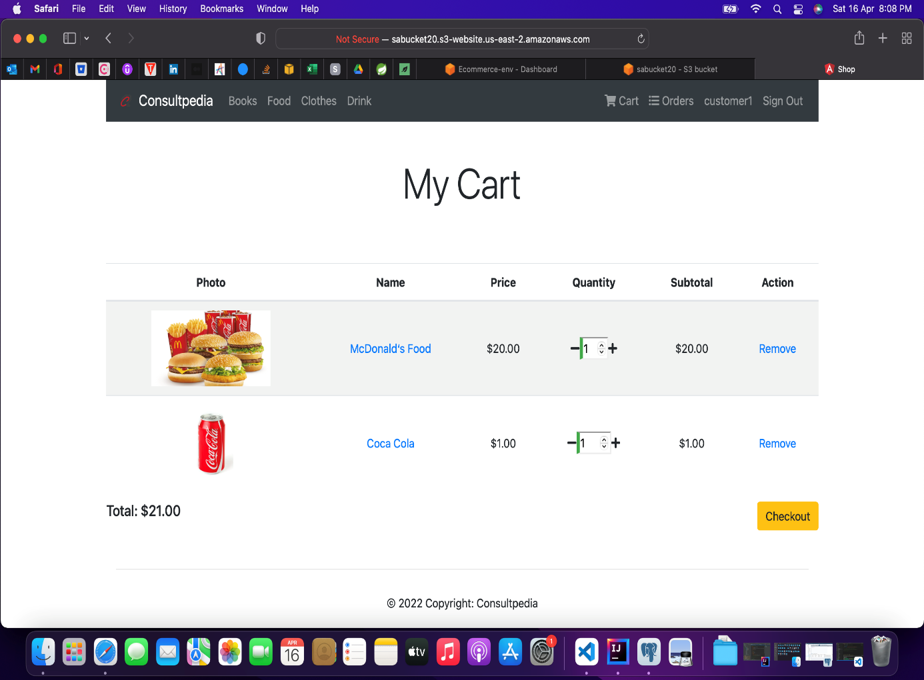

**Stock Page**

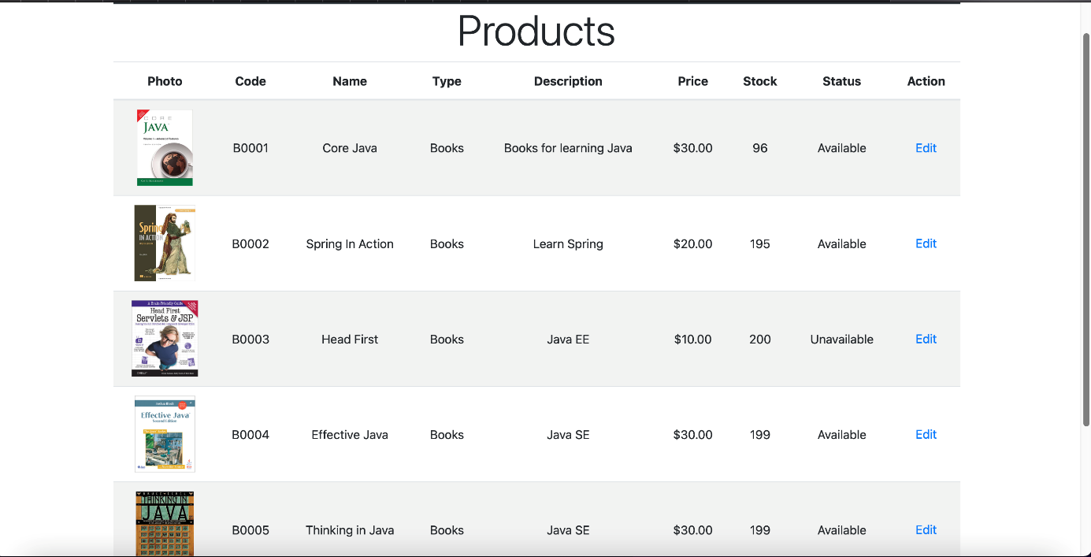

**61**

**Edit Stock Page**

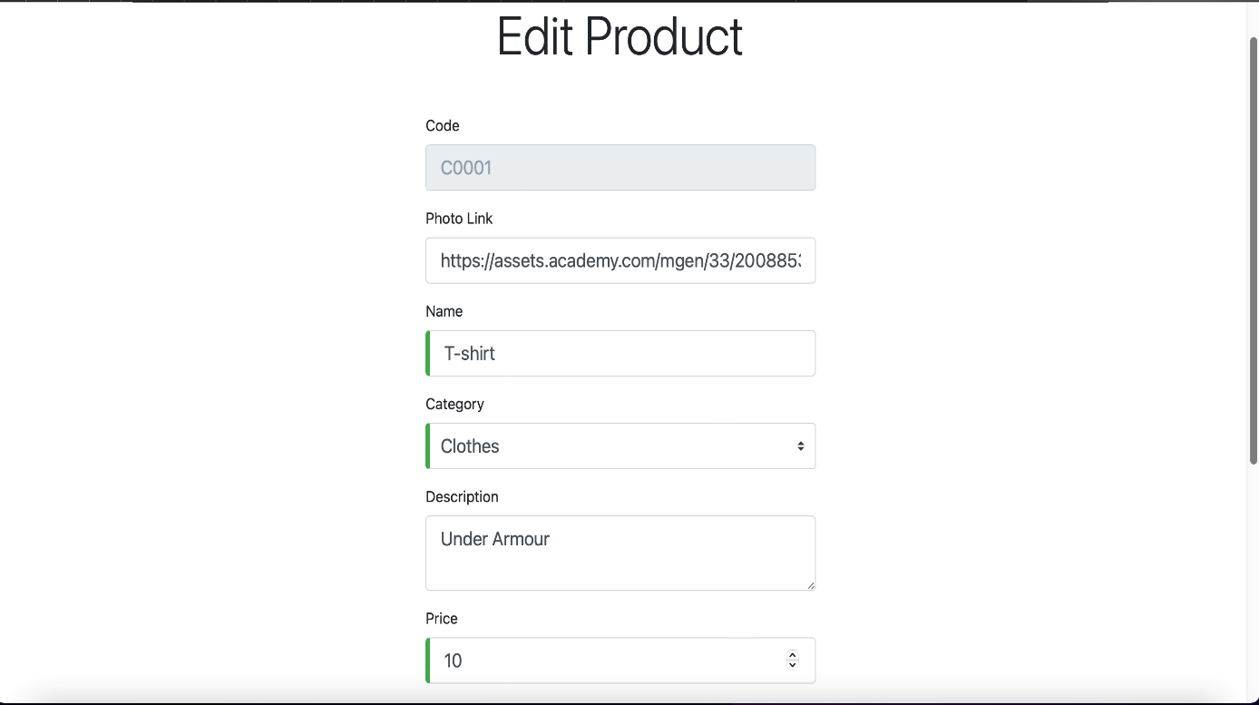

**Orders Page**

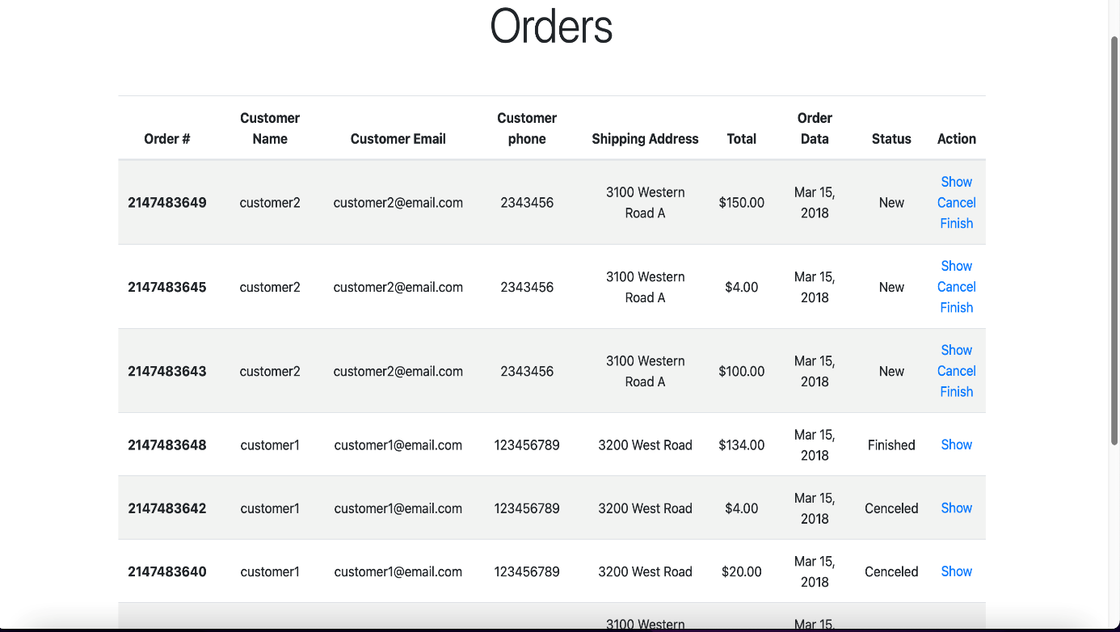

**62**

**Order Details Page**

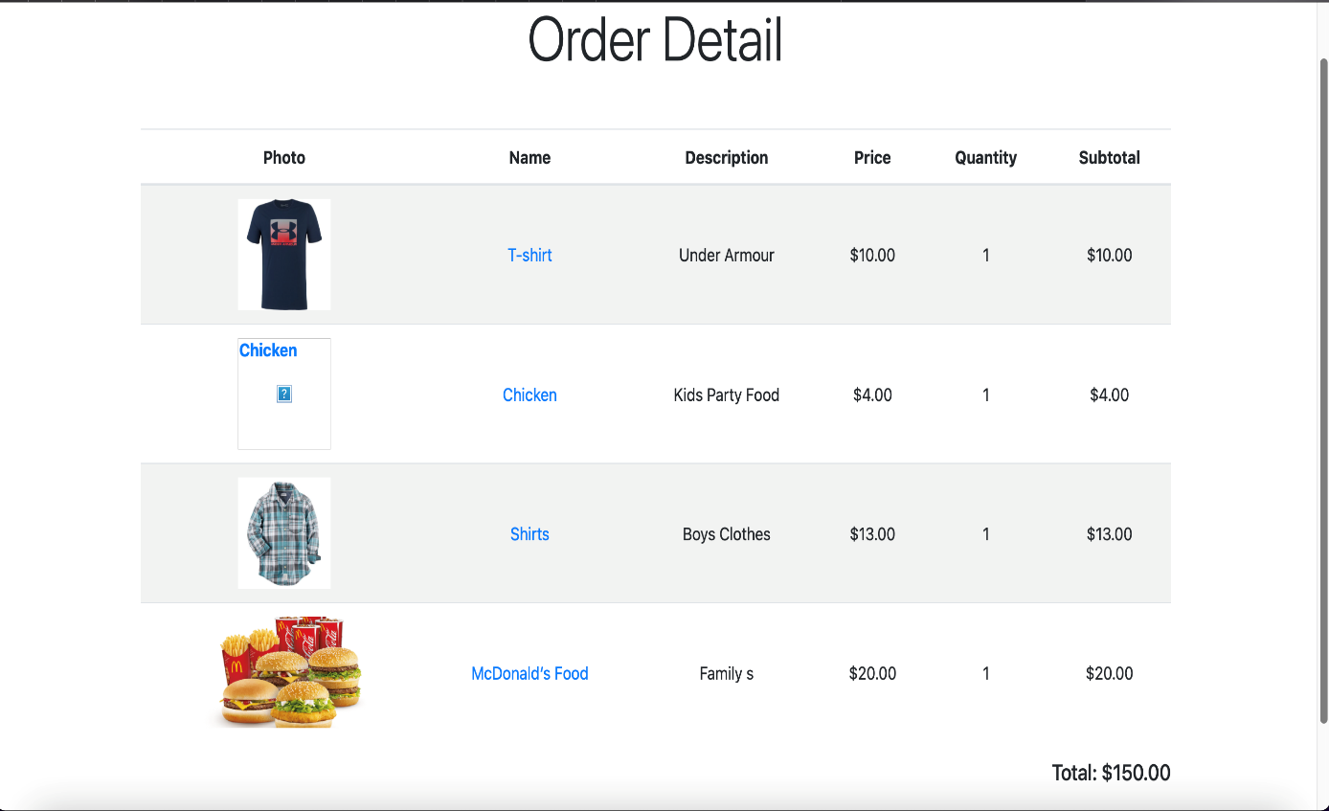

**Edit Profile Page**

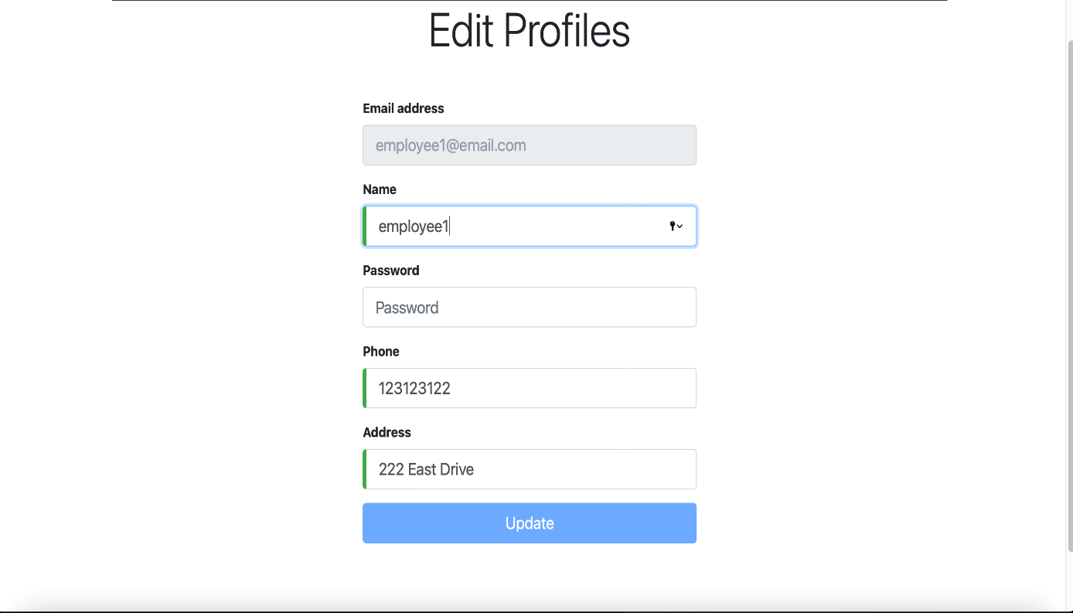

**63**

**Chapter-13**

**Additional Work (Research Paper)**

**13.1 Introduction:**

Research is "[creative](https://en.wikipedia.org/wiki/Creativity) and systematic work undertaken to increase the stock of knowledge". It involves the collection, organization and analysis of information to increase understanding of a topic or issue. A research project may be an expansion on past work in the field. To test the validity of instruments, procedures, or experiments, research may replicate elements of prior projects or the project as a whole.

The primary purposes of [basic research](https://en.wikipedia.org/wiki/Basic_research) (as opposed to [applied research](https://en.wikipedia.org/wiki/Applied_research)) are [documentation](https://en.wikipedia.org/wiki/Documentation), [discovery](https://en.wikipedia.org/wiki/Discovery_(observation)), [interpretation](https://en.wikipedia.org/wiki/Interpretation_(philosophy)), and the [research and development](https://en.wikipedia.org/wiki/Research_and_development) (R&D) of methods and systems for the advancement of human [knowledge](https://en.wikipedia.org/wiki/Knowledge). Approaches to research depend on [epistemologies](https://en.wikipedia.org/wiki/Epistemology), which vary considerably both within and between humanities and sciences.

**13.2 Overview:**

During the winter break, I also published a research paper on” **The effect of Amazon Web Services (AWS) on Cloud-Computing”**, in International Journal of Engineering Research & Technology (IJERT). It was published in Vol. 10 Issue 11 during November, 2021.

This paper provides an insight about the effects of Amazon Web Services (AWS) on cloud computing. How the things have been changed in cloud computing after the introduction of AWS and how it has helped to solve some of the traditional drawbacks of cloud computing.

Check that out here:

**https://www.ijert.org/the-effect-of-amazon-web-services-aws-on-cloud-computing**

**13.3 Some Screenshots:**

**64**

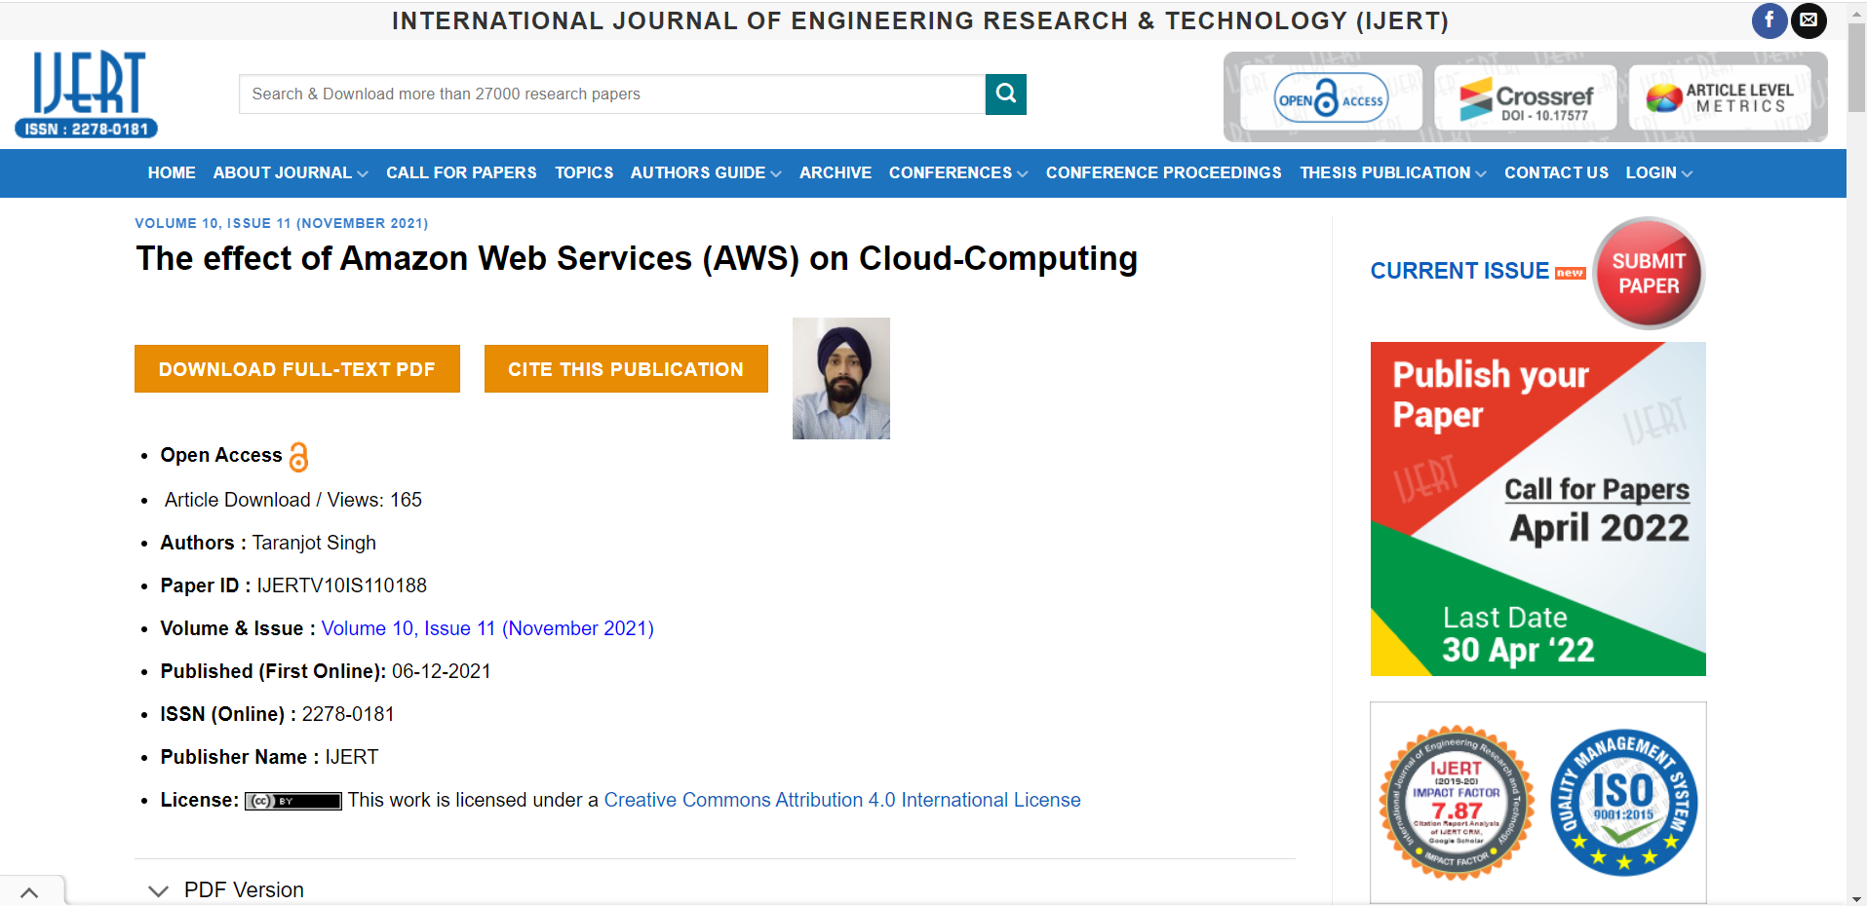

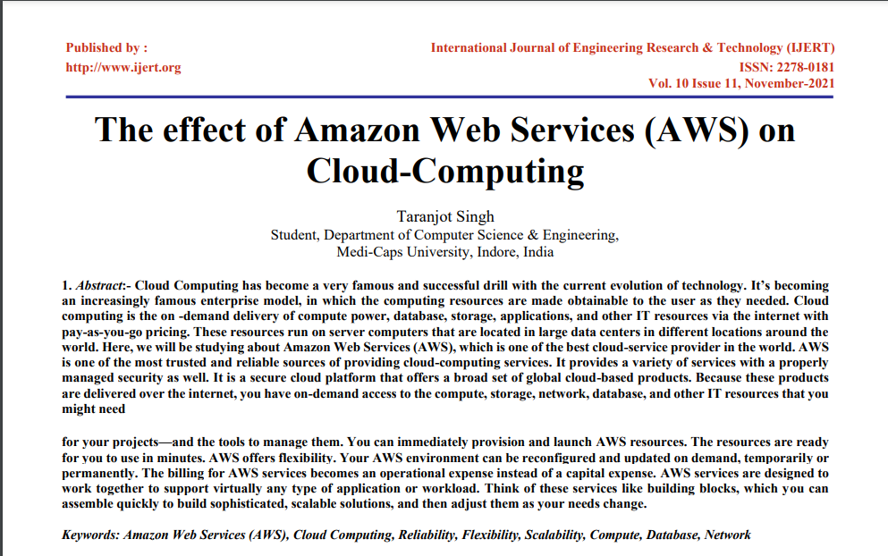

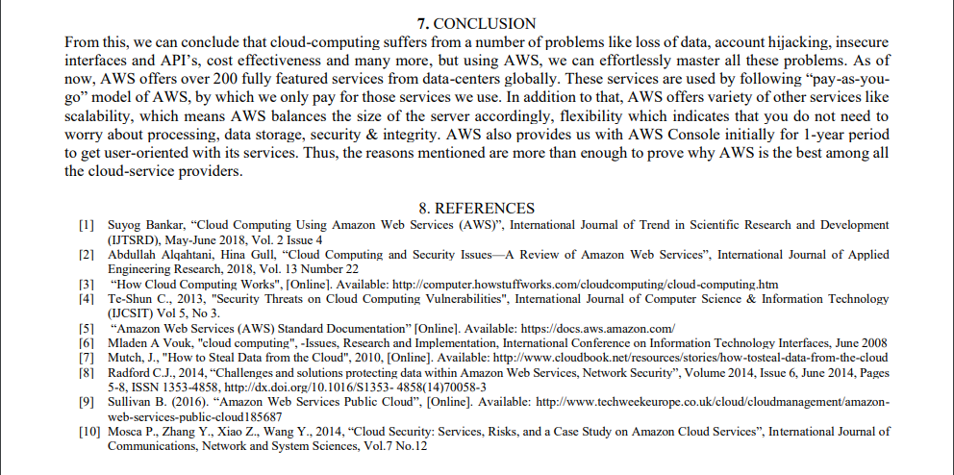

**65**

**Chapter-14**

**Executive Summary & Conclusion**

**14.1 Interpretation of the Project:**

The system has been implemented and tested successfully. It meets both functional and non-functional requirements specified to the great extent. Although the system has been designed keeping the present and future requirements in mind and made very flexible. But still there are some limitations of the system. Proper consideration has been given for a wide range of new enhancements. The system is developed in a user-friendly way. In future, if it is required to add new functionality in the system it can be simply achieved by just adding a separate module without affecting the design of the system, as our system properly follows MVC Architecture. It has helped us to properly maintain information about the distributors, customers, orders and medicine stocks. Furthermore, the maintenance of the project will become easy in future and transparency will be maintained.

**14.2 Future Scope:**

* Facility to signup/login with Google and other platforms.
* Can make use of Data Science Technology so that the employees can know about their frequently sold products and majority of their customers belongs to which area/city.
* Customers can give rating to the brands of products, so that other customers can know about the brand’s services which will help them to identify more accurately from which brand they can order products.

**14.3 My Learning Experience:**

Training and development are considered as a strategy for growth in the field of Computer Science and Information Technology. It is adopted by the organization to fill the gap between skills and future opportunities. These initial and advance training programs definitely enhance skills, improve efficiency, and productivity and growth opportunities for employees, mainly freshers. Skills, knowledge and attitudes are the basics for efficient running of a business through the human resources of an organization.

**66**

By improving the capabilities of employees, organizational capabilities can also be improved. In result, the structure of organization become flatter, in which there will be fewer levels between the top and the bottom employees. Many organizations provide coaching to their high-potential employees to develop their skills in creativity, thinking, innovation, vision, motivating others and brainstorming. Rather than putting the employees into management and expecting that they will develop their knowledge and skills on their own, organizations can systematically develop their skills through combination of these technical training and development programs. Evaluation of training must be appropriate for the persons and situations. The feedback from learners is important not only for instructors but also for confidence of the learner.

As a result of this training, I am now aware of all these technologies mentioned, and also contributing this knowledge in building the upcoming project.

I was also given a series of evaluations by mentor after the project shadowing phase, which I passed with utmost accuracy to provide the proof of learning and the ability to use that knowledge practically. And only after the proper approval by my mentor, I was assigned the project with the Epimoní̱s team.

To conclude, I must say that this learning experience really helped & motivated me to perform better as well as gave confidence to build real-life projects by myself. Everyone in my team is very helpful and solves all my queries. They also provided me valuable resources as well as their experiences to give me an insight of the real-life project.

**67**

**Chapter-15**

**Bibliography**

* *Spring Initializer.* [online] Available at: <<https://start.spring.io/>> [Accessed 5 January 2022]
* *Deploying Using Docker & Kubernetes.* [online] Available at: <www.google.com> [Accessed 6 January 2022]
* *Spring-Boot Tutorial.* [online] Available at: <<https://www.jetbrains.com/idea/>> [Accessed 8 January 2022]
* *Brave Browser.* [online] Available at: <<https://brave.com/>> [Accessed 10 January 2022]
* *Coding with VS Code.* [online] Available at: <<https://code.visualstudio.com/>> [Accessed 14 January 2022]
* *Learning Angular.* [online] Available at: <[www.angular.io](http://www.angular.io)> [Accessed 15 January 2022]
* *Python Frameworks.* [online] Available at: <<https://www.geeksforgeeks.org/>> [Accessed 23 January 2022]
* *Project Shadowing.* [online] Available at: <<https://en.wikipedia.org/wiki/>> [Accessed 24 January 2022]
* *Exploring MVC Architecture.* [online] Available at: <[www.tutorialspoint.com](http://www.tutorialspoint.com)> [Accessed 25 January 2022]
* *AWS Documentation.* [online] Available at: <<https://aws.amazon.com/>> [Accessed 27 January 2022]
* *JavaScript Documentation.* [online] Available at: <<https://developer.mozilla.org/en-US/docs/Web/JavaScript>> [Accessed 30 January 2022]
* *Java Tutorial.* [online] Available at: <[www.javatpoint.com](http://www.javatpoint.com)> [Accessed 2 February 2022]
* *Learn to Code.* [online] Available at: <[www.simplilearn.com](http://www.simplilearn.com)> [Accessed 5 February 2022]
* *Python Tutorial.* [online] Available at: <[www.w3schools.com](http://www.w3schools.com)> [Accessed 7 February 2022]
* *Introduction- MS Power BI.* [online] Available at: <<https://powerbi.microsoft.com>> [Accessed 10 February 2022]

**68**

* *Collaborate Projects Using Trello.* [online] Available at: <[www.trello.com](http://www.trello.com)> [Accessed 16 February 2022]
* *JIRA Software.* [online] Available at: <[www.atlassian.com](http://www.atlassian.com)> [Accessed 18 February 2022]
* *Learn Salesforce.* [online] Available at: <[www.salesforce.com](http://www.salesforce.com)> [Accessed 20 February 2022]
* *Edrawsoft. 2021.* Diagrams Made Simple. [online] Available at: <<https://www.edrawmax.com/>> [Accessed 12 April 2022].
* *App.diagrams.net. 2021. Flowchart Maker & Online Diagram Software.* [online] Available at: <https://app.diagrams.net/> [Accessed 15 April 2022].

**69**